School closure: Mon27 th- 1st May Senior Infants
English | Jolly Phonics:  Revise Jolly phonics Sound for the week: ie .  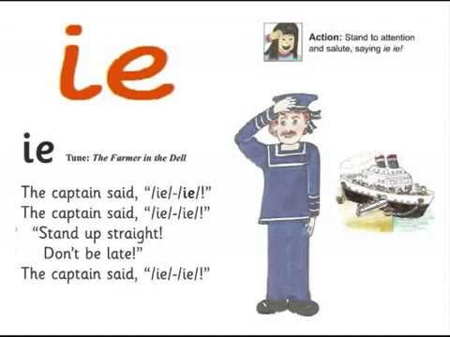  The song can be found in this video. It starts 1minute in. Copy and paste this link into the browser https://www.youtube.com/watch?v=jJzSTbDBjjQ  Listen a few times during the week. Look at the picture above and tell mammy or daddy things that have that sound in them.  See how many words you can write with that “ie” sound .  Sounds Like Phonics Book: Pg. 63, 64 complete pages  Rhyme of the Week: “ice”. Help your child think of words that rhyme with “ice”  Write 4 or more words into their writing copy.  Weekly Story:  Listen to Avocado Baby by John Burningham.  https://www.youtube.com/watch?v=cKLmcn_38tU  Ask them questions about the story  -What made the baby strong? Think of something you could eat to make you strong.  What was your favourite part?  Write 2 sentence about the story. Tell it to mammy and daddy first and then write it into your copy. E.g I Like the baby . He is strong. Again, praise them for their efforts.  Draw a picture from the story at the top of the writing page.  .  If your child wants too, you can use seesaw to take a photo of your child’s writing and picture and send it to me. When you open the Seesaw app, you will see this activity in your child’s journal.  Writing:  Skills book B: if they have a skills book, complete the next 2 pages.  Reading:  Keep reading their book each day and reading their wordlists or flashcards. If you need a new wordlist, please contact me.  In seesaw, there is an assignment where your child can record themselves reading 3 pages of their book. Again, only do this if you have time or if your child wants to..
Maths: | Keep revising Left and Right: Learn which hand is left and right.  Busy at Maths pg 80 and pg 84.  3 minute Exercise: do this a few times a week, mammy or daddy call out a sum with a total up to 10 and you add t in your head! If finding this hard, draw it out for your child.  2 fun games. Copy link into browser.  https://www.topmarks.co.uk/maths-games/mental-maths-train  Select +, up to10-one more  game https://www.topmarks.co.uk/ordering-and-sequencing/caterpillar-ordering. Click into sequencing 1-10  2 minute exercise: mammy or daddy call out any numbers between 1 and 10 (or up to 15 if you want) and you write them down.
Irish | Bua Na cainte:  Open Ceacht 3, 4, 5 this week and listen to the lessons.  The most important parts are the comhrá ( the speech bubble icon) and the games icon. In the games section, just pick one or 2 games for each lesson, as there can be a lot of games.  If you cannot access Bua na cainte on a laptop, here’s an alternative:  Download Cúla4 app onto your phone or the kids tablet. It has 2 parts to it "spraoi" and " Feach". When downloaded, click into spraoi and then into "Eadach" icon and children can hear the names and pronunciation for all the clothes.  The 4 sentence to practise with the clothes vocabulary are:  Tá ( briste) orm: I have trousers on. So ask your child what they are wearing and they can give you a few sentences using this new phrase e.g Tá stocai orm/ Ta t-leine orm.  Nil ( geansaí ) orm. : I dont have a jumper on.  Cuir ort do stocai : Put on your socks. This is a sentence for you to ask your child. Put on your socks etc.. Use it with different clothes. Good idea to do in the morning.  Bain díot do chóta : Take off your coat. Again, use with different items of clothing
The world around us | Map activtiy:  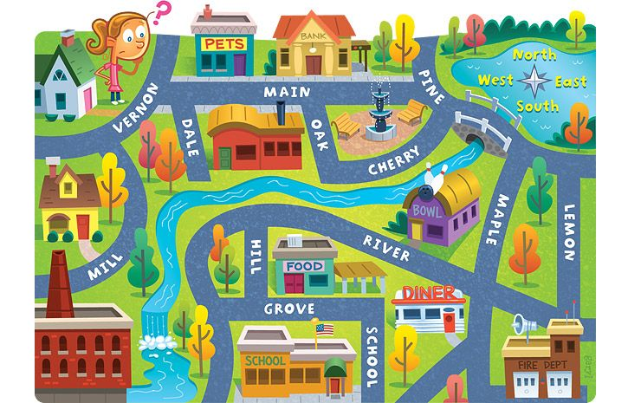  - Trace the girls path to school.  - Tell mammy or daddy what she must pass to get to school.  - What things must she pass to get to the pond.  - Trace her path to the fire station. What things does she pass.  Plant Needs:  Listen to the song about what plants need to grow.  https://www.youtube.com/watch?v=dUBIQ1fTRzI  Do you remember the 5 things they need. Tell mammy or daddy.
PE | Have a look at the activities Ms. Foley is posting on the school website- active school tab.  Skills Challenge this week!  Chest pass throw;( used when playing basketball).  • See can you chest pass the ball to a partner 10 times without either of you dropping it. If you drop it, go back to the start.  - Chest pass it again to your partner but let it bounce once between ye.  Good luck!

