School closure: Mon27april – 1st may Junior Infants
English | New Jolly phonics Sound for the week: ie .  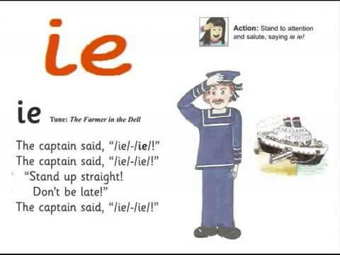  The song can be found in this video. It starts 1minute in. Copy and paste this link into the browser https://www.youtube.com/watch?v=jJzSTbDBjjQ  Listen a few times during the week. Look at the picture above and tell mammy or daddy things that have that sound in them  Parents may write down the suggestions so children can see the “ie” sound. (tie/pie etc)  If you can,, write these new sound on card and stick into their word envelopes for regular revision.  Rhyme of the Week: “ ip”. Help your child think of words that rhyme with “ip”.  Write 4 or more into their writing copy. Encourage them to keep the letters on the line, and make the tall letters tall.  Weekly Story:  Listen to Avocado Baby by John Burningham.  https://www.youtube.com/watch?v=cKLmcn_38tU  Ask them questions about the story  -What made the baby strong? Think of something you could eat to make you strong.  What was your favourite part?  Write one sentence about the story. Tell it to mammy and daddy first and then write it into your copy. Encourage your child to keep the sentence simple. E.g I Like the baby/ He is funny/ He is strong. Again, praise them for their efforts. This can be hard for them.  Again, if your child is finding it really difficult to get started, you can write the sentence into their copy and they can copy it underneath.  Draw a picture from the story at the top of the writing page.  If your child wants too, you can use seesaw to take a photo of your child’s writing and picture and send it to me. When you open the Seesaw app, you will see this activity in your child’s journal.  Just handwriting book: complete pg. 23 y.  Letter Formation: Practise writing these letters this week : n, k, e h ,d  Spend a few minutes each session practising these letters.  Make sure your child is writing them correctly. Make sure they always start their letters from the top. Pick another letter you know your child is finding hard to write, and practise that each day too.  Skills Book A: Complete pgs 32,33  Reading: Keep reading their book each day and reading their wordlists or flashcards. If you need a new wordlist, please contact me.  In seesaw, there is an assignment where your child can record themselves reading 3 pages of their book. Again, only do this if you have time or if your child wants to.
Maths: | Complete the counting game https://www.topmarks.co.uk/ordering-and-sequencing/caterpillar-ordering Click into sequencing 1-10  Fun activity here. Kids will enjoy this as a warm up activity. Copy and paste url in to browser.  Capacity: get children to look at 4 or 5 containers which can hold liquid. Make sure they are empty. Children decide which holds most/least. They can put them in order. After , fill with water to check.  Complete pages 96 and 97 in BUSY AT Maths workbook  Keep this up each week (2-3 minutes each day): Many or daddy call out any number up to 5 and you write it down. If this is too easy, push them on to writing numbers up to 10. Ask them to add numbers for you up to 5. E.g. 1+1/ 2+1 etc. Again, push them on if they are finding this easy.  Feed teddy some cakes: https://www.topmarks.co.uk/learning-to-count/teddy-numbers  Every day activities: Keep practising days of the week and counting up to 10 and even up to 20! Tell mammy every morning what day it is! Tell her what was yesterday and what day will it be tomorrow.
Irish | Bua Na cainte:  Open Ceacht 3, 4, 5 this week and listen to the lessons.  The most important parts are the comhrá ( the speech bubble icon) and the games icon. In the games section, just pick one or 2 games for each lesson, as there can be a lot of games.  If you cannot access Bua na cainte on a laptop, here’s an alternative:  Download Cúla4 app onto your phone or the kids tablet. It has 2 parts to it "spraoi" and " Feach". When downloaded, click into spraoi and then into "Eadach" icon and children can hear the names and pronunciation for all the clothes.  The 4 sentence to practise with the clothes vocabulary are:  Tá ( briste) orm: I have trousers on. So ask your child what they are wearing and they can give you a few sentences using this new phrase e.g Tá stocai orm/ Ta t-leine orm.  Nil ( geansaí ) orm. : I dont have a jumper on.  Cuir ort do stocai : Put on your socks. This is a sentence for you to ask your child. Put on your socks etc.. Use it with different clothes. Good idea to do in the morning.  Bain díot do chóta : Take off your coat. Again, use with different items of clothing
The world around us | Map activtiy:  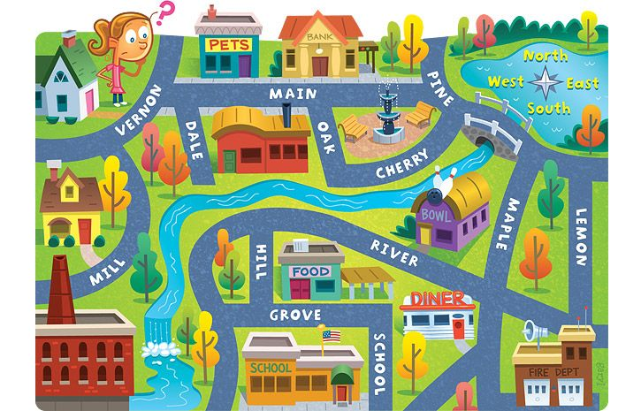  - Trace the girls path to school.  - Tell mammy or daddy what she must pass to get to school.  - What things must she pass to get to the pond.  - Trace her path to the fire station. What things does she pass.  Plant Needs:  Listen to the song about what plants need to grow.  https://www.youtube.com/watch?v=dUBIQ1fTRzI  Do you remember the 5 things they need. Tell mammy or daddy.
PE | Have a look at the activities Ms. Foley is posting on the school website- active school tab.  Skills Challenge this week!  Chest pass throw;( used when playing basketball).  • See can you chest pass the ball to a partner 10 times without either of you dropping it. If you drop it, go back to the start.  - Chest pass it again to your partner but let it bounce once between ye.  Good luck

