School closure: Mon20th- 24th April Senior Infants
English | Jolly Phonics:  Revise Jolly phonics Sound for the week: oa . The action is to bring your hand over your mouth, as if something had gone wrong and say “Oh”  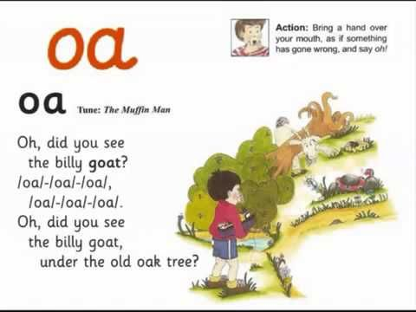  Copy and paste this link into the browser to hear the sound https://www.youtube.com/watch?v=0sM4JVgym40  Listen a few times during the week. Look at the picture above and tell mammy or daddy things that have that sound in them.  . Set a timer and see how many words you can write with that “Oa” sound in 3 minutes.  Can you remember a word which starts with bl/ br/ gl/gr. Tell mammy or daddy.  Sounds Like Phonics Book: Pg. 61, 62 complete pages  Rhyme of the Week: “aw”. Help your child think of words that rhyme with “aw”  Write 4 or more words into their writing copy.  Listen to these story The Girl, the bear and the magic shoes” by Julia Donaldson. https://www.youtube.com/watch?v=-jqf66uKZi4  Have your child retell the story. What was your favourite part? Ask them what other chasing stories do we know?? (Gingerbread man).  In their writing copies children can write anywhere between 2-4 sentences the bear. E.g. what he looks like/ his personality.  Writing:  Just handwriting: complete pg. 33.  Skills book B: if they have a skills book, complete the next 2 pages.  Reading:  Keep reading their book each day and reading their wordlists or flashcards.
Maths: | Left and Right: Learn which hand is left and right.  Tip to remember: when holding up your left hand, your index finger and thumb make the shape of a capital L. Try it! This will help you remember which is which.  Busy at Maths: complete pages 77, and 78 (a map).  3 minute Exercise: do this a few times a week, mammy or daddy call out a sum with a total up to 10 and you add t in your head! If finding this hard, draw it out for your child.  2 minute exercise: mammy or daddy call out any numbers between 1 and 10 (or up to 15 if you want) and you write them down.  Extras: lots more games on websites : www.topmarks.co.uk
Irish | If you have managed to download the bua na cainte B app to your laptop ( see instructions on our class web page), we will look at learning about “Eadai” ( clothes) for next few weeks.  Open Ceacht 1 and 2 this week and listen to the lessons.  The most important parts are the comhrá ( the speech bubble icon) and the games icon. In the games section, just pick one or 2 games for each lesson, as there can be a lot of games.  Get the children to practise these words for all the different clothes throughout the week- in the morning when getting dressed, or at bedtime.  Doing 10 minutes each day would be great, but just do what your child can manage.
The world around us | Parts of a plant  Remember the parts of a plant: Stem/leaf/root/petal.  Watch this video to learn a little more  https://www.youtube.com/watch?v=p3St51F4kE8  Draw and colour a flower showing all these different parts.  Draw a simple map :  Draw a map from your house to a shop or to school or to granny’s house.  Draw the map putting in the things you pass by on the way.
PE | Have a look at the activities Ms. Foley is posting on the school website- active school tab.  One idea this week- make an obstacle course in your garden. No pressure of course, just getting out into your garden and running about or playing football is sufficient too!  I will try to give you a skills challenge each week!  Here’s this week’s challenge for you!  Using an underarm throw;  • How many times can you do that throw in 30 seconds?  • Can you change something about the throw? (Higher, lower, longer, shorter)

