School closure: Mon20th- 24 April Junior Infants
English | New Jolly phonics Sound for the week: oa . The action is to bring your hand over your mouth, as if something had gone wrong and say “Oh”  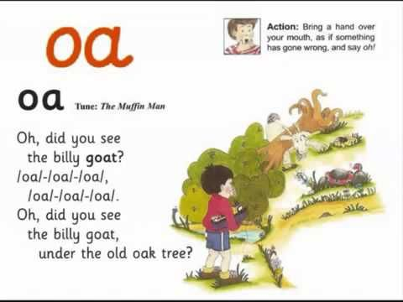  The song can be found on the same video as the “ai” sound. Revise the ai sound again and then listen to this new sound. Copy and paste this link into the browser https://www.youtube.com/watch?v=0sM4JVgym40  Listen a few times during the week. Look at the picture above and tell mammy or daddy things that have that sound in them. This is initially hard so parents can also come up with suggestions with their child. Parents may write down the suggestions so children can see the “Oa” sound.  If You have card at home, write these new sounds on card and stick them into their word envelopes for regular revision.  Rhyme of the Week: “ id”. Help your child think of words that rhyme with “id”.  Write 4 or more into their writing copy.Encouage them to keep the letters on the line, and make the tall letters tall.  Listen to these story The Girl, the bear and the magic shoes” by Julia Donaldson. https://www.youtube.com/watch?v=-jqf66uKZi4  Have your child retell the story. What was your favourite part? Ask them what other chasing stories do we know?? (Gingerbread man)  Draw a picture of a part they liked in the story. Ask them to tell you which character they liked. In their writing copy, they can write this sentence e.g. “I like the bear”. Let them write it whatever way they can. Spelling is not important at this stage. You want them to engage in writing so give them loads of praise for their effort! If your child is finding this really difficult to get started, you can write the sentence into their copy and they can copy it underneath.  Just handwriting book: complete pg. 21 u.  Sounds Like Phonics: pg. 77. Colour the pictures the correct colour.  Skills Book A:  Reading: Keep reading their book each day and reading their wordlists or flashcards.
Maths: | Complete the counting game https://www.topmarks.co.uk/learning-to-count/gingerbread-man-game  Busy at Maths Complete pg. ,92,93, 94  Many or daddy call out any number up to 5 and you write it down. If this is too easy, push them on to writing numbers up to 10. Ask them to add numbers for you up to 5. E.g. 1+1/ 2+1 etc. Again, push them on if they are finding this easy.  Keep practising days of the week and counting up to 10 and even up to 20! Tell mammy every morning what day it is!
Irish | If you have managed to download the bua na cainte A app to your laptop ( see instructions on our class web page), we will look at learning about “Eadai” ( clothes) for next few weeks.  Open Ceacht 1 and 2 this week and listen to the lessons.  The most important parts are the comhrá ( the speech bubble icon) and the games icon. In the games section, just pick one or 2 games for each lesson, as there can be a lot of games.  Get the children to practise these words for all the different clothes throughout the week- in the morning when getting dressed, or at bedtime.  Doing 10 minutes each day would be great, but just do what your child can manage.
The world around us | Parts of a plant  Remember the parts of a plant: Stem/leaf/root/petal.  Watch this video “ parts of a plant- Dr. Binocs” to learn a little more  https://www.youtube.com/watch?v=p3St51F4kE8  Draw and colour a flower showing all these different parts.  Draw a simple map :  Draw a map from your house to a shop or to school or to granny’s house.  Draw the map putting in the things you pass by on the way.
PE | Have a look at the activities Ms. Foley is posting on the school website- active school tab.  One idea this week- make an obstacle course in your garden. No pressure of course, just getting out into your garden and running about or playing football is sufficient too!  I will try to give you a skills challenge each week!  Heres this weeks challenge for you!  Using an underarm throw;  • How many times can you do that throw in 30 seconds?  • Can you change something about the throw? (Higher, lower, longer, shorter)

