School closure: May 4th-7th Senior Infants
English | Jolly Phonics:  Revise Jolly phonics Sound for the week: ee or.  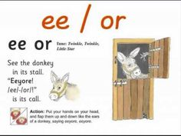  The song can be found in this video link. Copy and paste this link into the browser https://www.youtube.com/watch?v=W57mT4x488A  Listen a few times during the week. Look at the picture above and tell mammy or daddy things that have that sound in them  See how many words you can write with that “ee” sound and “or” sound.  Sounds Like Phonics Book: Pg. 65,66 complete pages  Rhyme of the Week: “ine”. Help your child think of words that rhyme with “ine”  Write 4 or more words into their writing copy.  Seesaw Activity:  Activity 1:Using seesaw, could you take a picture of this and send it to me. Would love to see their rhymes this week. Only if you get a chance or are able to do this. When you open the seesaw app, you will see it in their journal.  Weekly Story:  Listen to The Tiger Who Came to Tea by Judith Kerr  https://www.youtube.com/watch?v=BXgW9UCgpc8  Ask them questions about the story  -What did the Tiger eat and drink? What would you do if a tiger knocked on your door?  What was your favourite part?  In the story we hear about what foods the tiger ate, and we hear about what Sophie ate in the cafe.  What foods do you like to eat?  Write 3 or 4 sentences about your favourite foods e.g I like chips/ I love buns/ I love milk etc.. Write it into your writing copy. Draw a picture of these foods at the top of the page.  Seesaw activities:  Activity 2. If your child wants too, you can use seesaw to take a photo of your child’s writing and picture and send it to me. When you open the Seesaw app, you will see this activity in your child’s journal.  Phonics:  Seesaw App: Activity 3: In Seesaw journal. Move the picture to the correct sound.  Skills Book B: Complete next 2 pages if you have a skills book.  Reading: Keep reading their book each day and reading their wordlists or flashcards. If you need a new wordlist, please contact me.  Reading is the most important thing to keep up with your child. If you can, try to get a few minutes each day to listen to their reading and their wordlists or flashcards.
Maths: | Busy at Maths pg 85  Pg 86 and 87 and 88: Number 10.  Call out numbers to 10 each day and get your child to write them down. If too easy, keep adding more new numbers.  3 minute Exercise. Keep this practise up! Mammy or daddy call out a sum with a total up to 10 and you add in your head! If finding this hard, draw it out for your child.  New game https://www.topmarks.co.uk/ordering-and-sequencing/caterpillar-ordering. Click into sequencing 20-1
Irish | Bua Na cainte:  Sa Bhaile  Open Ceacht 1,2,3,4 this week and listen to the lessons.  The most important parts are the comhrá ( the speech bubble icon) and the games icon. In the games section, just pick one or 2 games for each lesson, as there can be a lot of games.  Keep revising colours with them. Point out things around the house and garden ask them to tell you the colour. These can be accessed by downloading cula4 app to your phone. Click into “Dathanna”.  If you cannot access Bua na cainte , please let me know and I send on some irish resources.
The world around us | The frog Life cycle:  https://www.youtube.com/watch?v=-yZsabsIwS8&feature=youtu.be  Listen to this story on youtube. I hope you enjoy it. Then draw the frog lifecycle with mammy or daddys help. Hint: there are just 3 stages.  Garden Hunt:  Print this off and find something in your garden  which is each of these colours. If you don’t have access to a printer, use crayons to create this for your child.  The file link is on the website.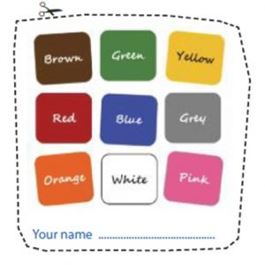
PE | Have a look at the activities Ms. Foley is posting on the school website- active school tab.  Skills Challenge this week!  - Kick the ball to a partner back and forth for 2 minutes.  - Kick the ball into the goals or btween 2 cones. How many times can you do that in 2 minutes.  - Kick the ball as hard as you can, . Try this 5 times.  Extra Activity: can you skip with a skipping rope? Practise this week. It might seem hard at first but take your time and keep practising!
Art | A parent in our school is collecting pictures to send to front line staff. If any child would like to draw a picture to say thank you to front line staff,  Plesae let me know and I will forward on her email address.

