School closure: May 25th- 28th Senior Infants
English | Jolly Phonics:  Revise Jolly phonics Sound for the week: sh.  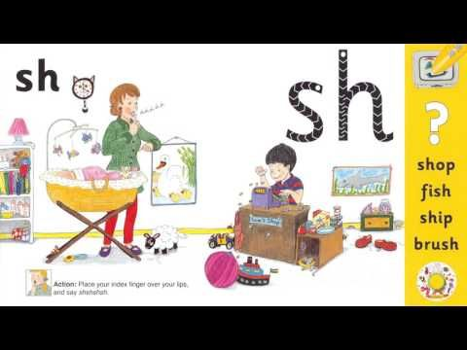  The song can be found in this video link. Copy and paste this link into the browser https://www.youtube.com/watch?v=DiTFrPBOkkU  Listen a few times during the week. Look at the picture above and tell mammy or daddy things that have that sound in them  See how many words you can write with that “sh” sound. E.g. ship/ shut etc  Sounds Like Phonics Book: pg 71 Revise Magic e.  Weekly sound: “ai” words. Can you remember any words with this sound?- hair/ pair/ pain/paint. Write 4 or more into your copy .  Weekly Story:  Listen to Giraffes Cant Dance by Giles Andrea  I have linked you to the story in Seesaw .  https://www.youtube.com/watch?v=vZjsLK5vwNU  Ask them questions about the story after listening:  -What was the jungle dance?  - Why did Gerald feel sad when it was time for the Jungle Dance  - Can you remember the names of some of the animals that started dancing?  - Who helped Gerald find a song to dance to?  - What was your favourite part?  Writing activity: “ My favourite African Animal”  Write 3 or 4 sentences telling me your favourite animal and why you like this animal.  .Seesaw activities: “ My favourite African Animal”  Activity 1. If your child wants too, you can use seesaw to take a photo of your child’s writing and picture and send it to me. When you open the Seesaw app, you will see this activity in your child’s journal  Skills Book B: Complete next 2 pages if you have a skills book  Seesaw Oral Language Activity: My News  Activity 3: If your child wants, they can record 2 or 3 lines of news they might want to tell me.  When you open the Seesaw app, you will see this activity in your child’s journal.  Reading: Keep reading their book each day and reading their wordlists or flashcards. If you need a new wordlist, please contact me.
Maths: | Busy at Maths  Time: Children will learn how to read the clock time “ O clock”. Show them how you make “ O clock” using the long big hand and the shortl hand. Children can complete pages: Pg. 97,98,99  https://www.topmarks.co.uk/time/teaching-clock  This will help you to show your child when an hour has passed ( when the clock hands do a full circle). When you open the link, click on “reset” so both hands are at 12 to make 12 o clock. Then click “ an hour” and it moves to 1 oclock, . Keep clicking on “ hour” to show them the next o clock times.  Data: Pg 100 Count the butterflies and ladybirds.  3 minute Exercise. Keep this practise up! Mammy or daddy call out a sum with a total up to 10 and you add in your head! If finding this hard, draw it out for your child.
Irish | Bua Na cainte:  An Teilifís  Open Ceacht 5,6,7,8 this week and listen to the lessons.  The most important parts are the comhrá ( the speech bubble icon) and the games icon. In the games section, just pick one or 2 games for each lesson, as there can be a lot of games.  If you cannot access Bua na cainte , please let me know and I will send on some irish resources.
The world around us | History:  Seesaw Activity 3: A holiday I went on  Where did you go? Who went with you? What did you do there? What was your favourite part?  Mammy or daddy can record you talking about your past holiday.  Garden birds  Look out for these birds this week.  The Magpie  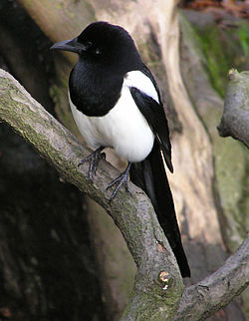  The Blue tit  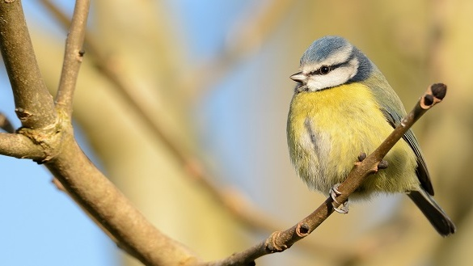
PE | Have a look at the activities Ms. Foley is posting on the school website- active school tab.  Skills Challenge this week!  Skills Challenge: Dance  - Dance to your favourite song  - Play musical statutes- mammy or daddy pause the song and you freeze.  - Let mammy or daddy pick a song and you dance with them, right to the end.  - Dance with a partner and copy each others dance moves.
Art | Paint or draw a butterfly.  I would love to see these. So if you get a chance to do this, please send me the picture on seesaw.

