School closure: Monday 25th- 28th Junior Infants
English | New Jolly phonics Sound for the week: sh.  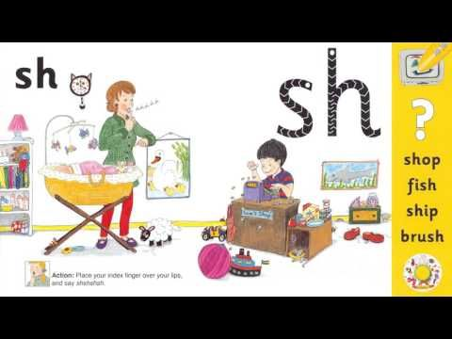  The song can be found in this video link. Copy and paste this link into the browser https://www.youtube.com/watch?v=DiTFrPBOkkU  Listen a few times during the week.  Look at the picture above and tell mammy or daddy things that have that sound in them. Maybe you know some other things which start with “sh”, or end with “sh”.  Write these new sounds on card and stick into their word envelopes for regular revision.  Rhyme of the Week: “ Ug”. Help your child think of words that rhyme with “ug”.  Write 4 or more into their writing copy.  Weekly Story:  Listen to Giraffes Cant Dance by Giles Andrea  I have linked you to the story in Seesaw .  https://www.youtube.com/watch?v=vZjsLK5vwNU  Ask them questions about the story after listening:  -What was the jungle dance?  - Why did Gerald feel sad when it was time for the Jungle Dance  - Can you remember the names of some of the animals that started dancing?  - Who helped Gerald find a song to dance too?  - What was your favourite part?  Writing activity: “ My favourite African Animal”  Write 2 sentences telling me yor favourite animal and why you like this animal.  Again, if your child is finding it really difficult to get started, you can write the sentence into their copy and they can copy it underneath.  Seesaw activities: “ My favourite African Animal”  Activity 1. If your child wants too, you can use seesaw to take a photo of your child’s writing and picture and send it to me. When you open the Seesaw app, you will see this activity in your child’s journal.  Just handwriting book: complete pg. 31.  Skills Book A: Complete pgs 40,41.  Seesaw Oral Language Activity: My News  Activity 3: If your child wants, they can record 2 or 3 lines of news they might want to tell me.  When you open the Seesaw app, you will see this activity in your child’s journal.  Reading: Keep reading their book each day and reading their wordlists or flashcards. If you need a new wordlist, please contact me.
Maths: | Maths games:  Day and Night: What is the difference between day and night?What things do you do during the day and what do you do at night time?  Busy at Maths pg 110 amd 111  Money: Ask mammy or daddy to show you a 1c, 2c, 5 c coin. Complete pg 115 in workbook, and page 116 ( adding money)  Money game:  https://www.topmarks.co.uk/money/toy-shop-money/eur  Click into 1 coin, then 1c. ( make sure its in cent not pence)
Irish | Bua Na cainte:  An Teilifís  Open Ceacht 5,6,7,8 this week and listen to the lessons.  The most important parts are the comhrá ( the speech bubble icon) and the games icon. In the games section, just pick one or 2 games for each lesson, as there can be a lot of games.  Revision: Using cúla 4 app, revise aimsir (weather)  If you cannot access Bua na cainte , please let me know and I will send on some Irish resources.
The world around us | History:  Seesaw Activity 3: A holiday I went on  Where did you go? Who went with you? What did you do there? What was your favourite part?  Mammy or daddy can record you talking about your past holiday.  Garden birds  Look out for these birds this week.  The Magpie  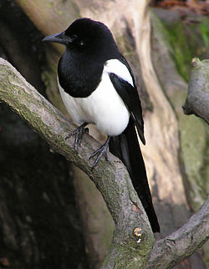  The Blue tit  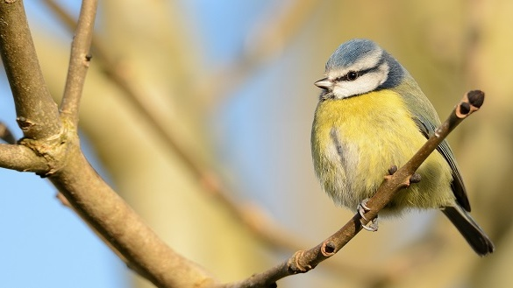
PE | Have a look at the activities Ms. Foley is posting on the school website- active school tab.  Skills Challenge this week!  Skills Challenge: Dance  - Dance to your favourite song  - Play musical statutes- mammy or daddy pause the song and you freeze.  - Let mammy or daddy pick a song and you dance with right to the end.  - Dance with a partner and copy each others dance moves.
Art | Paint or draw a butterfly.  I would love to see these. So if you get a chance to do this, please send me the picture on seesaw.

