School closure: Monday 18th– 22nd May Junior Infants
English | New Jolly phonics Sound for the week: ch.  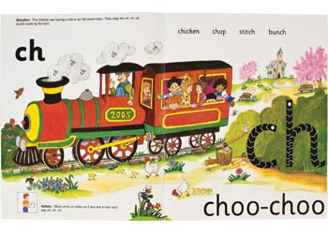  The song can be found in this video link. Copy and paste this link into the browser https://www.youtube.com/watch?v=ieYAY2uXvtg  Listen a few times during the week.  Look at the picture above and tell mammy or daddy things that have that sound in them. Maybe you know some other things which start with “Ch”, or end with “ch”.  Write these new sounds on card and stick into their word envelopes for regular revision.  Rhyme of the Week: “ Un”. Help your child think of words that rhyme with “un”.  Write 4 or more into their writing copy. Encourage them to keep the letters on the line, and make the tall letters tall.  Weekly Story:  Listen to Elmer by David Mc Kee  I have linked you to the story in Seesaw .  https://www.youtube.com/watch?v=wdyo4ykh2WA  Ask them questions about the story after listening:  -Why did Elmer cover himself with berries?  - Why did all the elephants start laughing?  - What is Elmers’ Day and what happens on that day?  What was your favourite part?  Writing activity: “What did Elmer look like?”  Write 1 or 2 sentences about him e.g He was pink/ He was yellow/ He wsa big/ He had big ears. He had a trunk.  Again, if your child is finding it really difficult to get started, you can write the sentence into their copy and they can copy it underneath.  Seesaw activities:  Activity 1. If your child wants too, you can use seesaw to take a photo of your child’s writing and picture and send it to me. When you open the Seesaw app, you will see this activity in your child’s journal.  Sounds Like Phonics Workbook: pg. 81  Just handwriting book: complete pg. 29  Letter Formation: Practise writing these letters this week : w,v,y, x  Spend a few minutes each session practising these letters.  Make sure your child is writing them correctly. Make sure they always start their letters from the top. Pick another letter you know your child is finding hard to write, and practise that each day too.  Skills Book A: Complete pgs 38,39.  Seesaw Oral Language Activity: Show and Tell  Activity 2 Pick something you would like to show me e.g a toy /medal/ book/a flower . Then tell me 3 or 4 sentences about the object e.g who gave it to you/ where you got it/ why you love it etc Practise with mammy or daddy first before recording.  When you open the Seesaw app, you will see this activity in your child’s journal.  Reading: Keep reading their book each day and reading their wordlists or flashcards. If you need a new wordlist, please contact me.  Seesaw : Reading Activity3 ;  Record yourself reading 2 to 3 pages of your reader and send it to me. Remember to tell me the name of the story at the start.
Maths: | Maths games:  Shape and Pattern game : https://www.topmarks.co.uk/ordering-and-sequencing/shape-patterns . Click on level 1  Counting : https://www.topmarks.co.uk/learning-to-count/underwater-counting  Click into “Up to 10”  Adding sets to 5: Busy at maths pg 108,109  Every day activities: The Usuals! Days of the week, counting up and back to 20, name the 4 seasons.
Irish | Bua Na cainte:  An Teilifís  Open Ceacht 1,2,3,4 this week and listen to the lessons.  The most important parts are the comhrá ( the speech bubble icon) and the games icon. In the games section, just pick one or 2 games for each lesson, as there can be a lot of games.  Revision: Using cúla 4 app, revise aimsir (weather)  If you cannot access Bua na cainte , please let me know and I will send on some Irish resources.
The world around us | African Animals:  If you have a globe or a map at home, mammy or daddy could show you where Africa is.  Here is a story about some animals you might see in Africa. The only animal that you would not see in Africa is the Tiger. You would have to go to Asia to see him!  Story: Walking through the Jungle  https://www.youtube.com/watch?v=tKPJbuP0g04. After the story, see can you name all the animals in this story.  Watch this link to learn some more facts about Africa:  https://www.youtube.com/watch?v=PSYHMWmyVfo  If you want, you can draw a picture of some of these african animals and send it to me on seesaw. I would love to see it!  Garden birds  Look out for these 2 birds this week.  The Blackbird  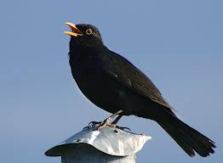  The Thrush  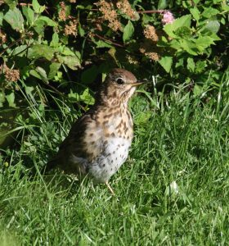
PE | Have a look at the activities Ms. Foley is posting on the school website- active school tab.  Skills Challenge this week!  This week it’s a mix of skills to practise  - Run as fast as you can on the spot for 10 seconds  - Jog around your garden for 90 seconds.  - Kicking skills: For 10 minutwa, take turns with a partner scoring goals, and goalkeeping.  - Skip with your rope for 2 minutes.  - Bounce pass a ball to your partner for 2 minutes.
Art | Draw a picture of Elmer !  Try to remember all the different colours he is.  If you don’t want to draw him and you have access to a printer, I have attached an Elmer colouring sheet for you.
Music | If its something you think , your child might be interested in, Dabbledoo are providing a free 4 week music course for parents to complete with their child. Lessons here for each class. They are lovely, easy to follow lessons . Copy and paste url to browser to register:  https://dabbledoomusic.com/p/parents-subscription-full-access

