School closure: Monday 11th– 15th may Junior Infants
English | New Jolly phonics Sound for the week: ng.  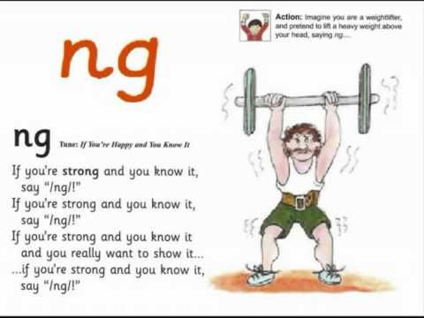  The song can be found in this video link. Copy and paste this link into the browser https://www.youtube.com/watch?v=a3dpKh789G4  Listen a few times during the week. Look at the picture above and tell mammy or daddy things that have that sound in them.  Children can find this sound difficult so parents may help their child come up with and write down the suggestions so children can see “ng “sound. i.e. ring/ strong/ bang etc.  Write these new sounds on card and stick into their word envelopes for regular revision.  Rhyme of the Week: “ et”. Help your child think of words that rhyme with “et”.  Write 4 or more into their writing copy. Encourage them to keep the letters on the line, and make the tall letters tall.  Weekly Story:  Listen to The Bog Baby by Jeanne Willis and Gwen Millward.  I have linked you to the story in Seesaw .  https://www.youtube.com/watch?v=nVuH4BdVQOQ  Ask them questions about the story after listening:  -Where did they find the bog baby? Why did they not tell mammy? What did he look like?  What did they give him to eat?  What was your favourite part?  Writing activity: What did the Bog baby look like?  Write 1 or 2 sentences about him e.g He was soft/ He was blue/ he had wings..  Again, if your child is finding it really difficult to get started, you can write the sentence into their copy and they can copy it underneath.  Seesaw activities:  Activity 1. If your child wants too, you can use seesaw to take a photo of your child’s writing and picture and send it to me. When you open the Seesaw app, you will see this activity in your child’s journal.  Rhyming activity:  Seesaw App: Activity 2: In Seesaw journal. Match the rhyming pictures  Sounds Like Phonics Workbook: pg. Write the Word  Just handwriting book: complete pg. 27 n.  Letter Formation: Practise writing these letters this week :n,f, b, j, z  Spend a few minutes each session practising these letters.  Make sure your child is writing them correctly. Make sure they always start their letters from the top. Pick another letter you know your child is finding hard to write, and practise that each day too.  Skills Book A: Complete pgs 36,37  Seesaw Oral Language Activity: My News  Activity 3: Every Monday morning in school, we would start the day by listening to each other’s weekend news. I would love to give them the chance to tell their news again. When you open the Seesaw app, you will see this activity in your child’s journal.  Reading: Keep reading their book each day and reading their wordlists or flashcards. If you need a new wordlist, please contact me.  Reading is the most important thing to keep up with your child. If you can, try to get a few minutes each day to listen to their reading and their wordlists or flashcards.
Maths: | Complete the counting https://www.topmarks.co.uk/learning-to-count/ladybird-spots  Here’s a ladybird counting game. Click on ordering, 1-10. Copy and paste url in to browser.  Days of the week: pg 106, 107. Trace the words. Colour, only if want to.  Zero: Adding sets with zero. Busy at maths pg 103,104,105  Adding two to a set: ask your child to add one more to numbers up to 5. You can use crayons, buttons etc. to show them this. You can write the sum for them after so they can see it what it looks like.  Every day activities: The Usuals! Days of the week, counting up and back to 20, name the 4 seasons.
Irish | Bua Na cainte:  Sa Bhaile  Open Ceacht 5,6,7,8 this week and listen to the lessons.  The most important parts are the comhrá ( the speech bubble icon) and the games icon. In the games section, just pick one or 2 games for each lesson, as there can be a lot of games.  Revision: Using cúla 4 app, revise part s of the body.  If you cannot access Bua na cainte , please let me know and I will send on some irish resources.
The world around us | Summer:  What changes happen in summer? Take a look in your garden and observe changes in plants, animals, flowers etc. Are you seeing more bees and butterflies? Are we dressing differently? Do you need to drink more water? Why?  What things can you see in summertime?  Draw a summer picture with some of these things in it. If you want, you can share it with me on Seesaw. I would love to see it.  Garden birds  Have you see these birds in your garden? Draw a picture of the birds you see in your garden. Look out for these 2 this week. Next week, we will pick 2 more to look out for.  The Robin  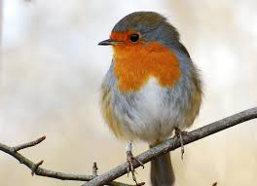:  The Swallow: You will know him by his fork tail  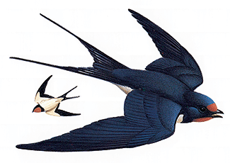
PE | Have a look at the activities Ms. Foley is posting on the school website- active school tab.  Skills Challenge this week!  - Run as fast as you can on the spot for 10 seconds  - Jog around your garden for 90 seconds.  - Jog on the spot doing high knees, then on your tip toes.  - Jog beside a partner, nice and slowly for 90 seconds.  - Run up and down your garden for 1 minute.  - Try to run without moving your arms for a few seconds. Is it possible?  Extra Activity: Keep practising your skipping rope skills.
Music |  | If its something you think , your child might be interested in, Dabbledoo are providing a free 4 week music course for parents to complete with their child. Lessons here for each class. They are lovely, easy to follow lessons . Copy and paste url to browser to register:  https://dabbledoomusic.com/p/parents-subscription-full-access

