School closure: May 11th- 15th Senior Infants
English | Jolly Phonics:  Revise Jolly phonics Sound for the week: ng.  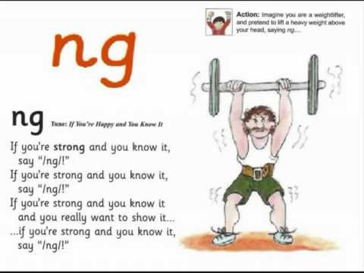  The song can be found in this video link. Copy and paste this link into the browser https://www.youtube.com/watch?v=a3dpKh789G4  Listen a few times during the week. Look at the picture above and tell mammy or daddy things that have that sound in them  See how many words you can write with that “ng” sound. E.g. ring/ sang/ long  Sounds Like Phonics Book: Pg. 67,68 complete pages  Rhyme of the Week: “ow”. Help your child think of words that rhyme with “ow”  Write 4 or more words into their writing copy...  Weekly Story:  Listen to The Bog Baby by Jeanne Willis and Gwen Millward.  I have linked you to the story in Seesaw.  https://www.youtube.com/watch?v=nVuH4BdVQOQ  Ask them questions about the story after listening:  -Where did they find the bog baby? Why did they not tell mammy? What did he look like?  What did they give him to eat?  What was your favourite part?  Writing activity: What did the Bog baby look like?  Write 3 or 4 sentences about him e.g. He was soft/ He was blue/ he had wings..  Seesaw activities:  Activity 1. If your child wants too, you can use seesaw to take a photo of your child’s writing and picture and send it to me. When you open the Seesaw app, you will see this activity in your child’s journal.  Phonics:  Seesaw App: Activity 2: In Seesaw journal Can you crack the 4 secret code words.  Skills Book B: Complete next 2 pages if you have a skills book.  Just handwriting: pgs. 33, 34. Practice Aa, Hh.  Seesaw Oral Language Activity: My News  Activity 3: Every Monday morning in school, we would start the day by listening to each other’s weekend news. I would love to give them the chance to tell their news again. When you open the Seesaw app, you will see this activity in your child’s journal  Reading: Keep reading their book each day and reading their wordlists or flashcards. If you need a new wordlist, please contact me.  Reading is the most important thing to keep up with your child. If you can, try to get a few minutes each day to listen to their reading and their wordlists or flashcards.
Maths: | Busy at Maths :  Pg. 89.90,91,92: Number 10.  3 minute Exercise. Keep this practise up! Mammy or daddy call out a sum with a total up to 10 and you add in your head! If finding this hard, draw it out for your child.  New https://www.topmarks.co.uk/maths-games/hit-the-button Click into “add 1-10”, or if want to challenge them more “ad 1-20”  Revise Days of the week with your child, 4 seasons, writing their numbers to 10.
Irish | Bua Na cainte:  Sa Bhaile  Open Ceacht 5,6,7,8 this week and listen to the lessons.  The most important parts are the comhrá ( the speech bubble icon) and the games icon. In the games section, just pick one or 2 games for each lesson, as there can be a lot of games.  Revision: Using cúla 4 app, revise part s of the body.  If you cannot access Bua na cainte , please let me know and I will send on some irish resources..
The world around us | Summer:  What changes happen in summer? Take a look in your garden and observe changes in plants, animals, flowers etc. Are you seeing more bees and butterflies? Are we dressing differently? Do you need to drink more water? Why?  What things can you see in summertime?  Draw a summer picture with some of these things in it. If you want, you can share it with me on Seesaw. I would love to see it.  Garden birds  Have you see these birds in your garden? Draw a picture of the birds you see in your garden. Look out for these 2 this week. Next week, we will pick 2 more to look out for.  The Robin  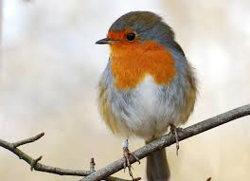:  The Swallow: You will know him by his fork tail
PE | Have a look at the activities Ms. Foley is posting on the school website- active school tab.  Skills Challenge this week!  - Run as fast as you can on the spot for 10 seconds  - Jog around your garden for 90 seconds.  - Jog on the spot doing high knees, then on your tip toes.  - Jog beside a partner, nice and slowly for 90 seconds.  - Run up and down your garden for 1 minute.  - Try to run without moving your arms for a few seconds. Is it possible?  Extra Activity: Keep practising your skipping rope skills.
Music | If its something you think , your child might be interested in, Dabbledoo are providing a free 4 week music course for parents to complete with their child. Lessons here for each class. They are lovely, easy to follow lessons. Copy and paste url to browser to register:  https://dabbledoomusic.com/p/parents-subscription-full-access

