May 25th 2020
Hi again fifth class.
You are doing really well and following all the guidelines from the Government and Health Team and well done.
Am enjoying correcting any work you get to put on Seesaw and remember you can always just email a picture of work to me and I will look it over and chat you back about it.
This week just carry on as below and if you didn’t get all last week’s work done that’s fine too but finish that before you move on to the new stuff because as you know Maths work is like building blocks and each new piece needs you to know the piece before.
Remember- do a Master your Maths section every day and then some of the other work. It’s not all for one day. You do what you can each day and do your best. We are very nearly finished the mental maths and that’s great.
Each day try to do as much of one Master your Maths day as possible and when you reach the test take 20-25 mins and do as much of the test as you can in that time.
Each day also please do some from the list below in the order they are given for that topic. The reason you need to do them in order as the easier ones for practice are always first!
For some I might ask you to try and look at the interactive examples that we often watch in school to help. For these you go to the CJ fallon homepage and click into Primary/5th class/maths/Busy at Maths/Busy at Maths 5th class/interactives and then go to the number I have mentioned.

This week we have two activities on seesaw, one is a kahoot on equivalent fractions and the other is about The parts of the circle. WE are also doing a little more on Number Theory and Chance and finishing area.
.

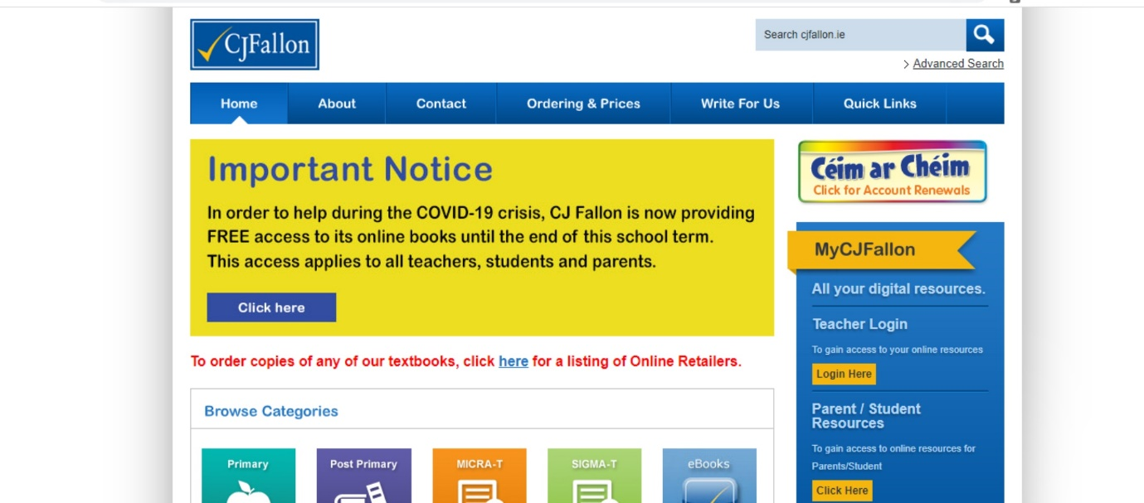

Area and Perimeter:
As we often remind ourselves: perimeter is the distance around the outside of a place/shape or object. Eg – you would walk the perimeter of the garden for exercise.
Area is the space covered by a shape or place. Eg - what area is the floor of the bedroom to out a carpet on it?
If you got to do the activity on irregular shapes in seesaw that’s great or the one with the lego.
P118 is all about the picture on p118 showing a map of an archaeological dig. Do your best to answer Q1-5 in your copy. (Just write A- B- etc.. for Q2 no need to draw the table)

Number Theory ch 26.
P145 is all about odd and even numbers. Just read the examples and fill in this page either in the book or in your copy.
P146 is all about numbers with shape – complete Q1 b,d,and f in your copy.
Try Q2 a and c.
Do b and d in Q3
Read through Q5 and then try Q6 by filling in the table and the diagram in the book or in your copy.
Chance – ch 33
If you didn’t get to do p 178 last week try it this week.
If you did go on to p180 and try any 2 of 1-4. Again you can write them in your copy or in the book.
Again do what you can manage and don’t worry we will figure out the rest when we get back- just do your best. It’s not all for one day so spread it out.
You can email me queries on info@pulloughns.com or you can send me a pic attached of a completed page if you are delighted with it.
Maths are all around you at all times and if you are baking or building at home you are learning real life maths at all times!!!!!
Marguerite White

