Hi boys and girls in Third Class.

You have done super work in Maths so far children. Keep it up! If you have any questions or would like me to correct your work, you can contact me on Seesaw. From Ms Foley.

There is no Master Your Maths this week at all.
There is no work for Friday as that would have been a day off school.
We are going to continue decimals this week. We will watch the tutorials again and complete some questions.

To access Busy at Maths Tutorials:
- Press Ctrl and Click here cjfallon.ie
- Click Parent/Student Resources in the blue box on the right hand side of the page.
- Click on Student Resources.
- Select Primary/3rd Class/ Maths/ Busy at Maths3 – Third Class/ Interactive
- Go through the pages to find the Tutorial number you want.

This week’s math topic = Decimals
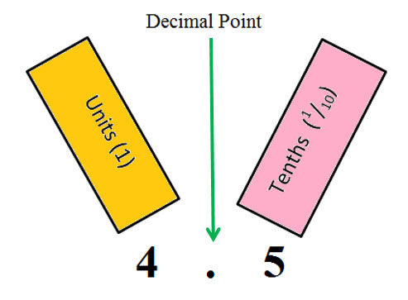

Here is recommended Maths for week of May 25th – 29th.
LOOK - There are further activities suggested on the next page for you to try or think about during this week!

Monday
Watch Tutorial 62
Complete Q4-Q5-Q6 on page 113 – in your copy
Tables – multiplying by 2 and dividing by 2 [read your tables book aloud or write them out]
Numberock Song: Press Ctrl and click on this link: Numberock Multiples of 2

Tuesday
Watch Tutorial 63
Complete Q2 on page 114– in your copy
Tables – multiplying by 2 and dividing by 2 [read your tables book aloud or write them out]
Numberock Song: Press Ctrl and click on this link: Numberock Multiples of 2

Wednesday
Complete Q4 on page 114 in copies
Tables – multiplying by 2 and dividing by 2 [read your tables book aloud or write them out]
Numberock Song: Press Ctrl and click on this link: Numberock Multiples of 2

Thursday
Tables Test – parents may set you a written tables test [a mix of multiplication and division 2’s]

Other Activities - FUN with Decimals

- Decimals all around us!

- Look for decimal numbers in the world around you. They may be found on price tags, in magazines, on kitchen items etc.

- Straws Activity:

- Cut a straw into 10 equal parts. [Each part is called one tenth. We write it as 1/10 or 0.1]
- Draw a notation board on an A4 sheet of paper. [H,T,U, , 1/10]
Hundreds | Tens | Units |  | Tenths

The numbers to the left of the decimal point are whole numbers.
The numbers on the right of the decimal point are only a fraction. [less than 1 whole]

- Make a variety of numbers using straws on your notation board or get someone else to do it and you write the answers.

- Use 1 whole straw for the whole numbers and use your smaller pieces [tenths] for the tenths house.

- You could use a special colour for each house – Hundreds/Tens/Units if you like.

- Calculator Fun
- Enter 0.1 into a calculator
- Keep pressing the equals sign – the display will count up in tenths! [0.1, 0.2, 0.3, etc.]
- Stop at 0.9 – what do you think will be the next decimal number?

