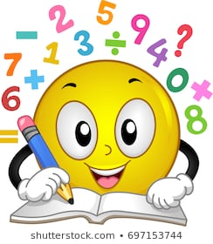
Hi boys and girls in Third Class.
You have been doing great work in Maths – well done! I know it’s not easy to keep up with your schoolwork during this time but remember maths is all around us!

There are only 2 weeks of Master Your Maths left so we are going to spread it out. We will do 2 days per week only – on Mondays and Fridays. On the other 3 days you can watch tutorials and do questions in a copy.

To access Busy at Maths Tutorials:
- Press Ctrl and Click here cjfallon.ie
- Click Parent/Student Resources in the blue box on the right hand side of the page.
- Click on Student Resources.
- Select Primary/3rd Class/ Maths/ Busy at Maths3 – Third Class/ Interactive
- Go through the pages to find the Tutorial number you want.

This week’s math topic = Decimals
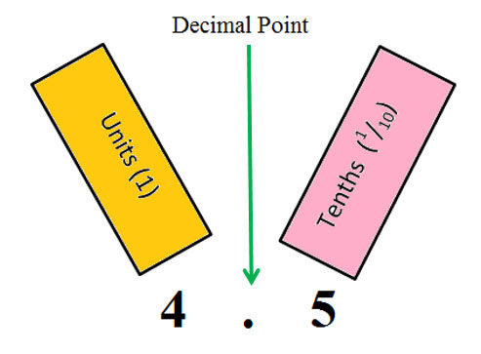

Here is recommended Maths for week of May 18th – 22nd.
LOOK - There are further activities suggested on the next page for you to try or think about during this week!
Ms Dunne has put up a Math activity on See-Saw – you can complete this week: Telling the Time Game

Monday
Master Your Maths – Week 29 –Monday
Tables – multiplying by 12 and dividing by 12 [read your tables book aloud or write them out]
Numberock Song: Press Ctrl and click on this link: Numberock Multiples of 12

Tuesday
Watch Tutorial 62
Complete Q3 on page 110 – in your copy
Tables – multiplying by 12 and dividing by 12 [read your tables book aloud or write them out]
Numberock Song: Press Ctrl and click on this link: Numberock Multiples of 12

Wednesday
Watch Tutorial 63
Complete Q 2 on page 112 in copies
Tables – multiplying by 12 and dividing by 12 [read your tables book aloud or write them out]
Numberock Song: Press Ctrl and click on this link: Numberock Multiples of 12

Thursday
Complete Q 4 on page 112 in copies
Tables – multiplying by 12 and dividing by 12 [read your tables book aloud or write them out]
Numberock Song: Press Ctrl and click on this link: : Numberock Multiples of 12

Friday
Master Your Maths – Week 29 –Tuesday
Tables Test – parents’ may set you a written tables test
Song: Press Ctrl and click on this link: Numberock Multiples of 12
Other Activities - FUN with Decimals

- Straws Activity:

- Cut a straw into 10 equal parts. [Each part is called one tenth. We write it as 1/10 or 0.1]
- Draw a notation board on an A4 sheet of paper. [H,T,U, , 1/10]
Hundreds | Tens | Units |  | Tenths

The numbers to the left of the decimal point are whole numbers.
The numbers on the right of the decimal point are only a fraction. [less than 1 whole]

- Make a variety of numbers using straws on your notation board or get someone else to do it and you write the answers.

- Use 1 whole straw for the whole numbers and use your smaller pieces [tenths] for the tenths house.

- You could use a special colour for each house – Hundreds/Tens/Units if you like.

- Calculator Fun

- Enter 0.1 into a calculator
- Keep pressing the equals sign – the display will count up in tenths! [0.1, 0.2, 0.3, etc.]
- Stop at 0.9 – what do you think will be the next decimal number?

