SN Muire Naofa, Pullough
Internet Acceptable Use Policy
(updated June 2020)
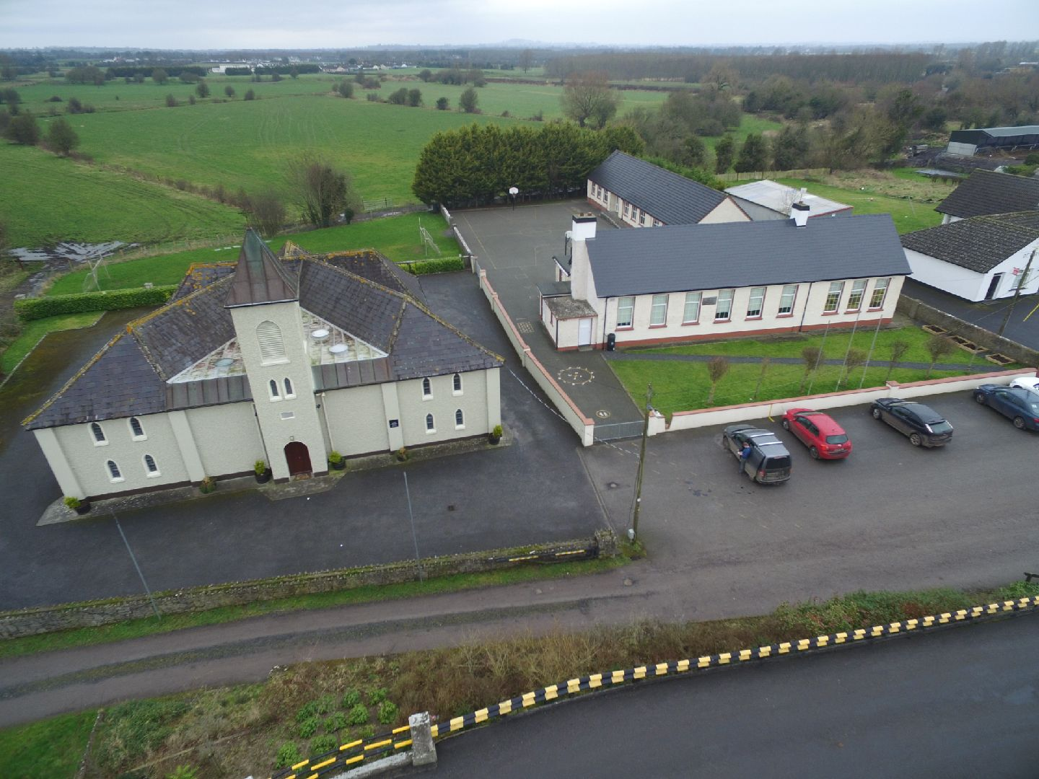

Address | Pullough, Tullamore, Co Offaly R35K521
Telephone | 05793555642
Email | pulloughns@gmail.com
Website | https://www.pulloughns.weebly.com
Fax
School Name | SN Muire Naofa
Date of Commencement | 09/02/1935
Author | Marguerite White
Contents

1. Introduction
2. General Approach
3. Content Filtering
4. Web Browsing and Downloading
5. Email and Messaging
6. Social Media
7. Personal Devices
8. Images & Video
9. Cyberbullying
10. School Websites
11. Permission Form

General Approach

The aim of this Internet Acceptable Use Policy (AUP) is to ensure that pupils will benefit from the learning opportunities offered by the school’s internet resources in a safe and effective manner.
Internet use and access is considered a school resource and privilege. If the school AUP is not adhered to this privilege may be withdrawn and appropriate sanctions will be imposed.

When using the internet pupils, parents and staff are expected:

This Acceptable Use Policy applies to pupils who have access to and are users of the internet in SN Muire Naofa .

- It also applies to members of staff, volunteers, parents, carers and others who access the internet in SN Muire Naofa .

Misuse of the internet may result in disciplinary action, including written warnings, withdrawal of access privileges, detention and, in extreme cases, suspension or expulsion. The school also reserves the right to report any illegal activities to the appropriate authorities.

SN Muire Naofa will deal with incidents that take place outside the school that impact on the wellbeing of pupils or staff under this policy and associated codes of behaviour and anti-bullying policies. In such cases SN Muire Naofa will, where known, inform parents/carers of incidents of inappropriate online behaviour that take place out of school and impose the appropriate sanctions.

SN Muire Naofa implements the following strategies on promoting safer use of the internet :

- Pupils will be provided with education in the area of internet safety as part of our implementation of the SPHE and CSPE curriculum.
- Internet safety advice and support opportiunities are provided to pupils in SN Muire Naofa through our ICT safety programmes and with teacher monitoring.
- Teachers will be provided with continuing professional development opportunities in the area of internet safety.
- SN Muire Naofa participates in Safer Internet Day activities to promote safer more effective use of the internet.

This policy and its implementation will be reviewed annually by the following stakeholders:

- Board of Management, teaching staff, support staff, pupils, and parents

This policy has been reviewed in light of the Covid-19 Pandemic by a working group including: Principal, In-school Management Team and with imput from the BOM and best practice guides from PDST and Webwise.

The school will monitor the impact of the policy using:

- Logs of reported incidents.
- Monitoring logs of internet activity (including sites visited).
- Surveys and/or questionnaires of pupils, parents, and teaching staff.

Should serious online safety incidents take place, DLP ( Marguerite White) or DDLP (Brenda Dunne) should be informed. All staff (including SNA/Ancillary)are requested to report any serious online safety breaches reported to them/observed by them.

The implementation of this Internet Acceptable Use policy will be monitored by DLP (Principal) with the support of all staff and overseen by the BOM.

Content Filtering

SN Muire Naofa has chosen to implement the following level on content filtering on the Schools Broadband Network:

- Level 5 This level allows access to millions of websites including games and YouTube and allows access to personal websites category, and other similar types of websites, such as blogs but blocks access to websites belonging to the personal websites category and websites such as Facebook belonging to the Social Networking category.

Pupils taking steps to by-pass the content filter by using proxy sites or other means may be subject to disciplinary action, including written warnings, withdrawal of access privileges, detention and, in extreme cases, suspension or expulsion.

Web Browsing and Downloading

Pupils will not intentionally visit internet sites that contain obscene, illegal, hateful or otherwise objectionable materials.

Pupils will report accidental accessing of inappropriate materials in the classroom to their teacher.

Pupils will report accidental accessing of inappropriate materials in school but outside the classroom to their class teacher/teacher on duty who will report to the DLP/DDLP (Principal/Deputy Principal).
A pupil may also inform parents/SNA who can then contact/inform the appropriate liaison teacher in school.

Pupils and staff will not copy information from the internet without acknowledging the creator and referencing the source of the content.

Pupils and staff will be aware that any usage, including distributing or receiving information, school-related or personal, may be monitored for unusual activity, security and/or network management reasons.

Pupils will use the school’s internet connection only for educational and career development activities.

Pupils will not engage in online activities such as uploading or downloading large files that result in heavy network traffic which impairs the service for other internet users.

Pupils will not download or view any material that is illegal, obscene, and defamatory or that is intended to annoy or intimidate another person.

- Use of file sharing and torrent sites is allowed with staff permission.

- Downloading by pupils of materials or images not relevant to their studies is not allowed.

Email and Messaging

- The use of personal email accounts is only allowed at SN Muire Naofa with expressed permission from members of the teaching staff.

Pupils will not send any material that is illegal, obscene, and defamatory or that is intended to annoy or intimidate another person.

Pupils should immediately report the receipt of any communication that makes them feel uncomfortable, is offensive, discriminatory, threatening or bullying in nature and must not respond to any such communication.

Pupils should avoid opening emails that appear suspicious. If in doubt, pupils should ask their teacher before opening emails from unknown senders.

Social Media

The following statements apply to the use of messaging, blogging and video streaming services in SN Muire Naofa :

- Use of instant messaging services and apps including Snapchat, Whats Apps, G Chat etc. is allowed in SN Muire Naofa with express permission from teaching staff.
- Use of blogs such as Word Press, Tumblr etc. is allowed in SN Muire Naofa with express permission from teaching staff.
- Use of video streaming sites such as YouTube and Vimeo etc. is with express permission from teaching staff.

Staff and pupils must not use social media and the internet in any way to harass, insult, abuse or defame pupils, their family members, staff, other members of the SN Muire Naofa community

Staff and pupils must not discuss personal information about pupils, staff and other members of the SN Muire Naofa community on social media.

Staff and pupils must not use school email addresses for setting up personal social media accounts or to communicate through such media.

Staff and pupils must not engage in activities involving social media which might bring SN Muire Naofa into disrepute.

Staff and pupils must not represent your personal views as those of bring SN Muire Naofa on any social medium.

Personal Devices

Pupils using their own technology in school should follow the rules set out in this agreement, in the same way as if they were using school equipment.

The following statements apply to the use of internet-enabled devices such as tablets, gaming devices, and digital music players in SN Muire Naofa :

- Pupils are only allowed to bring personal internet-enabled devices into SN Muire Naofa with expressed permission from staff.
- Pupils are only allowed to use personal internet-enabled devices during lessons with expressed permission from teaching staff.
- Pupils are only allowed to use personal internet-enabled devices during social time with expressed permission from staff.

Images & Video

Care should be taken when taking photographic or video images that pupils are appropriately dressed and are not participating in activities that might bring the individuals or the school into disrepute.

At SN Muire Naofa, pupils must not take, use, share, publish or distribute images of others without their permission.

Taking photos or videos on school grounds or when participating in school activities is allowed once care is taken that no harm is done to staff or pupils of SN Muire Naofa and with the consent of all. (pupil consent via parents).

Taking photos or videos on school grounds or when participating in school activities is only allowed with expressed permission from staff.

Written permission from parents or carers will be obtained before photographs of pupils are published on the school website.

Pupils must not share images, videos or other content online with the intention to harm another member of the school community regardless of whether this happens in school or outside.

Sharing explicit images and in particular explicit images of pupils and/or minors is an unacceptable and absolutely prohibited behaviour, with serious consequences and sanctions for those involved. Sharing explicit images of other pupils automatically incurs suspension as a sanction.

Cyberbullying

When using the internet pupils, parents and staff are expected to treat others with respect at all times.

Engaging in online activities with the intention to harm, harass, or embarrass and another pupil or member of staff is an unacceptable and absolutely prohibited behaviour, with serious consequences and sanctions for those involved.

Measures are taken to ensure that staff and pupils are aware that bullying is defined as unwanted negative behaviour, verbal, psychological or physical, conducted by an individual or group against another person (or persons) and which is repeated over time. This definition includes cyber-bullying even when it happens outside the school or at night.

Measures are taken by SN Muire Naofa to ensure that staff and pupils are aware that bullying is defined as unwanted negative behaviour, verbal, psychological or physical, conducted by an individual or group against another person (or persons) and which is repeated over time. This definition includes cyber-bullying even when it happens outside the school or at night.

Isolated or once-off incidents of intentional negative behaviour, including a once-off offensive or hurtful text message or other private messaging, do not fall within the definition of bullying and will be dealt with, as appropriate, in accordance with the school’s code of behaviour.

The prevention of cyber bullying is an integral part of the anti-bullying policy of our school.

School Websites

Pupils will be given the opportunity to publish projects, artwork or school work on the internet in accordance with clear policies and approval processes regarding the content that can be loaded to the school’s website.

The website will be regularly checked to ensure that there is no content that compromises the safety, privacy, or reputation of students or staff.

Webpages allowing comments or user-generated content will be pre-moderated and checked frequently to ensure that they do not contain any inappropriate or offensive content.

The publication of student work will be coordinated by a teacher.

SN Muire Naofa will use only digital photographs, audio or video clips of focusing on group activities. Content focusing on individual students will only be published on the school website with parental permission.

Personal student information including home address and contact details will not be published on SN Muire Naofa web pages.

SN Muire Naofa will avoid publishing the first name and last name of pupils in video or photograph captions published online.

Permission Form

Legislation

The school will provide information where requested on the following legislation relating to use of the Internet which teachers, students and parents may familiarise themselves with:

Data Protection (Amendment) Act 2003
Child Trafficking and Pornography Act 1998
Interception Act 1993
Video Recordings Act 1989
The Data Protection Act 1988

This policy has been reviewed and updated in June 2020 in line with school policy and in response to increased use of online platforms and online media during the Covid -19 Pandemic and to have proper structures and protections in place going forward during return to school post-Covid.

It will be reviewed and ratified by the BOM/Staff and PA via email and in discussion in June 2020 and will be fully ratified during the first meeting(s) after closure.

Please see form on next page to be returned to school.
Both parents and pupils need to sign.

SN Muire Naofa Pullough.

Form to be returned to school:
Please review the attached school Internet Acceptable Use Policy, and sign and return this permission form to the Principal.

Student Consent:
I agree to follow the school’s Acceptable Use Policy on the use of the Internet. I will use the Internet in a responsible way and obey all the rules explained to me by the school.

Student’s Signature: __________________________
Date: ___________________

Parent Consent:

As the parent or legal guardian of the above student, I have read the Acceptable Use Policy and grant permission for my son or daughter or the child in my care to access the Internet.
I understand that Internet access is intended for educational purposes. I also understand that every reasonable precaution has been taken by the school to provide for online safety but the school cannot be held responsible if students access unsuitable websites.
In relation to the school website, I accept that, if the school considers it appropriate, my child’s schoolwork may be chosen for inclusion on the website.
I understand and accept the terms of the Acceptable Use Policy relating to publishing students’ work on the school website.

Signature: _____________________________ Date: ___________________
Address: ______________________________
______________________________
______________________________
______________________________
School Name: SN Muire Naofa, Pullough
Name of Student(s)______________________

……………………………………………………………………………………………………

