Additional Home Activities:
Maths:
6th Class are focused on Fractions, Decimals and Percentages this week. Topmarks.co.uk is a great resource for games, activities and learning tools for many maths topics. If you get a chance try out this activity matching fractions, decimals and percentages: https://www.topmarks.co.uk/maths-games/7-11-years/fractions-and-decimals
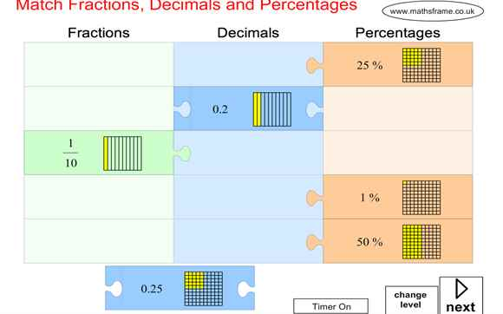

PE:
- PE lesson / workout with The Body Coach Joe Wicks every day. Can find his videos on this YouTube link https://www.youtube.com/user/thebodycoach1/featured
- Ms. Foley has some great active ideas on the school website. http://pulloughns.weebly.com/active-school.html
- Cosmic Kids Yoga on YouTube
Gaeilge
Bun go Barr 6: http://data.cjfallon.ie/resources/Rang6_Ceacht2.html
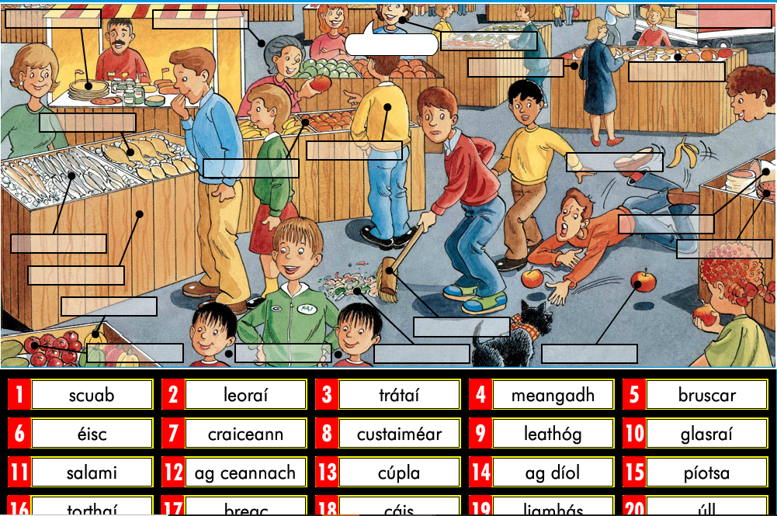
Religion:
Theme 8: Eucharist Lesson 1
At Mass We Give Thanks – Pages 82-85 Even though we are unable to attend mass at the minute, we can still take some time to give thanks. The Eucharist means thanksgiving and through our personal prayers at mass we give thanks to God for all that he has done and all the gifts he has given us.
English:
Handwriting Page 39 – Compound Words
Handwriting Page 40 – Occupations
SESE: History
https://www.museum.ie/en-IE/Museums/Natural-History/Visitor-Information/3D-Virtual-Visit
Virtual Tour of the Natural History Museum of Ireland.

