Monday 25.05.2020
English:
Spellbound: Week 31 Pages 64 and 65
- Read through all the block words and use a dictionary to help you find the meaning of the following words: exaggerate, except, estuary, souvenir, criticism
- Complete Exercise 1: Dictionary Work. Use the block words to solve the clues. This will help with your understanding of the list words.
- Learn Block 109
Above the Clouds: The Accident – Pages 224 - 231
- Pre – reading activities: Comprehension Strategy is Connecting Pg 224
- Read the full story in your book – This story is set during World War II. Bruno moves to a house beside a concentration camp where one of the prisoners is forced to work as a waiter in Bruno’s house. (Extract taken from The Boy in the Striped Pyjamas)
- Complete Exercise A – A Little Light Thinking Q1-6
Grammar Revision – Conjunctions
- A Conjunction is a word that joins words, phrases, clauses or sentence. e.g. but, and, yet, or, because, nor, although, since, unless, while, where etc.
- Examples: She bought a shirt and a book. I had to go to the shop because I ran out of milk.
- Exercise E Page 231 Above the Clouds. Question 1 a,b,c
Kahoot - https://kahoot.it/challenge/08269527?challenge-id=b5fcf698-f782-4d93-97a8-d0485c62fb60_1590362187242 Game Pin - 08269527
Gaeilge:
Léigh sa Bhaile: Seachtain 23 Lá 4 – Mise agus mo Chuid Mothúchán (Mé Féin)
- Léigh an scéal: http://data.cjfallon.ie/audio/LeighsaBhaile-E-p92.mp3 ctrl and click to listen to the story.
- Dictionary Work – fuath, chol ceathrar, gan stad, https://www.teanglann.ie/ga/
Fuaimeanna agus Focail: Aonad 29 An litir d’
- Ex A Líon na bearnaí le d’
- Ex B Cuir an focail chearta sna habairtí.
- Bosca 1
Maths: 6th Class
Busy at Maths: The Circle
- Page 147 – Drawing Circles
- Follow the three steps at the top of page 147. Try to use the compass to construct the circles in Question 1.
Mental Maths: Please complete Monday. Take a picture and upload to Seesaw I can correct for you.

Tuesday 26.05.2020
English:
Spellbound: Week 31 Pages 64 and 65
- Complete Exercise 2: Separate the words from blocks 111 and 112 into the correct boxes according to the amount of syllables they have.
- Complete Exercise 3: Synonyms Write words similar in meaning.
- Learn Block 110
Above the Clouds: The Accident – Pages 224 - 231
- Comprehension Strategy is Connecting Pg 224
- Re read the full story in your book – This story is set during World War II. Bruno moves to a house beside a concentration camp where one of the prisoners is forced to work as a waiter in Bruno’s house.
- Complete Exercise B – Deeper Thinking Pg 230
Grammar Revision – Prepositions
- Prepositions are words which link nouns, pronouns and phrases to other words in a sentence. Prepositions usually describe the position of something, the time when something happens and the way in which something is done.
- Example: Shine the lamp behind the screen. Put fasteners through the holes.
- Complete Exercise E Above the Clouds Q2 a,b,c
Gaeilge:
Léigh sa Bhaile: Seachtain 23 Lá 4 – Mise agus mo Chuid Mothúchán (Mé Féin)
- Léigh an scéal: http://data.cjfallon.ie/audio/LeighsaBhaile-E-p92.mp3 ctrl and click to listen to the story.
- Ceisteanna 1-5
Fuaimeanna agus Focail: Aonad 29 An litir d’
- Ex C Cuir le Chéile
- Ex D Scríobh 4 bhfocal ón liosta leis na litreacha
- Bosca 2
Maths: 6th Class
Busy at Maths: The Circle
- Page 147 – Drawing Circles
- Follow the three steps at the top of page 147. Try to use the compass to construct the circles in Question 2. Remember you have to find the radius of the circle before you can construct it. Radius is half the diameter.
Mental Maths: Please complete Tuesday. Take a picture and upload to Seesaw I can correct for you.

Wednesday 27.05.2020
English:
Spellbound: Week 31 Pages 64 and 65
- Complete Exercise 4: Write the block words that contain the smaller words listed.
- Complete Exercise 5: You will need to look for words with a double letter to solve some of the clues.
- Learn Block 111
Above the Clouds: The Holocaust Pages 232-237
- Comprehension Strategy – Scanning, Connecting, Inferring
- Read this factual piece about The Holocaust. The Holocaust was a period in history at the time of World War II (1939-1945), when millions of Jews were murdered because of who they were. The killings were organised by Germany’s Nazi Party, led by Adolf Hitler.
- Complete Exercise A – A Little Light Thinking 1-6
Grammar Revision – Contractions
- A contraction is a word made by shortening and combining two words.
- Examples: can't (can + not), don't (do + not), and I've (I + have) are all contractions.
- Exercise E page 231 Above the Clouds Q3 a,b,c

Gaeilge:
Léigh sa Bhaile: Seachtain 30 Lá 2 lth 118 – Cairde Nua (Mé Féin)
- Léigh an scéal: http://data.cjfallon.ie/audio/LeighsaBhaile-E-p118.mp3 ctrl and click to listen to the story.
- Dictionary Work – sa Fhrainc, bhuail, I ndiaidh, an-spraoi https://www.teanglann.ie/ga/
Fuaimeanna agus Focail: Aonad 29 An litir d’
- Ex F Tóirfhocal. Faigh na focail
- Ex G Scríobh an focal ceart faoin bpictiúr
- Bosca 3
Maths: 6th Class

Busy at Maths: The Circle
- Page 147 – Drawing Circles
- Follow the three steps at the top of page 147. Try to use the compass to construct the circles in Question 3. Use the same centre point on your page each time. Upload the picture of the three circles on Seesaw.
Mental Maths: Please complete Wednesday. Take a picture and upload to Seesaw I can correct for you.

Thursday 28.05.2020
English:
Spellbound: Week 31 Pages 64 and 65
- Complete Exercise 6: Fill in the boxes with letters that fit their shape.
- Learn Block 112
- Can complete a small spelling test at home if you wish.
Above the Clouds: The Holocaust Pages 232-237
- Comprehension Strategy – Scanning, Connecting, Inferring
- Read this factual piece about The Holocaust. The Holocaust was a period in history at the time of World War II (1939-1945), when millions of Jews were murdered because of who they were. The killings were organised by Germany’s Nazi Party, led by Adolf Hitler.
- Complete Exercise B – Deeper Thinking 1-6
Grammar Revision – Revision of Punctuation Marks
- Rewrite the sentences with full stops, (…) capital letters, (ABC) question marks, (???) exclamation marks, (‼!) apostrophes, (‘’’) commas (,,,) and quotation marks (”””) where necessary.
- Exercise E 1-5 Page 237 Above the Clouds.
Kahoot - https://kahoot.it/challenge/04455794?challenge-id=b5fcf698-f782-4d93-97a8-d0485c62fb60_1590362330568 Game Pin: 04455794

Gaeilge:
Léigh sa Bhaile: Seachtain 30 Lá 2 lth 118 – Cairde Nua (Mé Féin)
- Léigh an scéal: http://data.cjfallon.ie/audio/LeighsaBhaile-E-p118.mp3 ctrl and click to listen to the story.
- Ceisteanna 1-5
Fuaimeanna agus Focail: Aonad 29 An litir d’
- Ex E Críochnaigh na habairtí 1-4
- Ex H Crosfhocal
- Bosca 4
Maths: 6th Class
Busy at Maths: The Circle
- Page 147 – Drawing Circles
- Follow the three steps at the top of page 147. Question 4 Draw a circle with the radius 6cm and label the parts of the circle.
Mental Maths: Please complete Thursday. Take a picture and upload to Seesaw I can correct for you.

Additional Activities
English:
Handwriting: Page 41 Counting Chickens and Page 42 Group Words
Treasury 5: Conjunctions Page 51
Gaeilge:
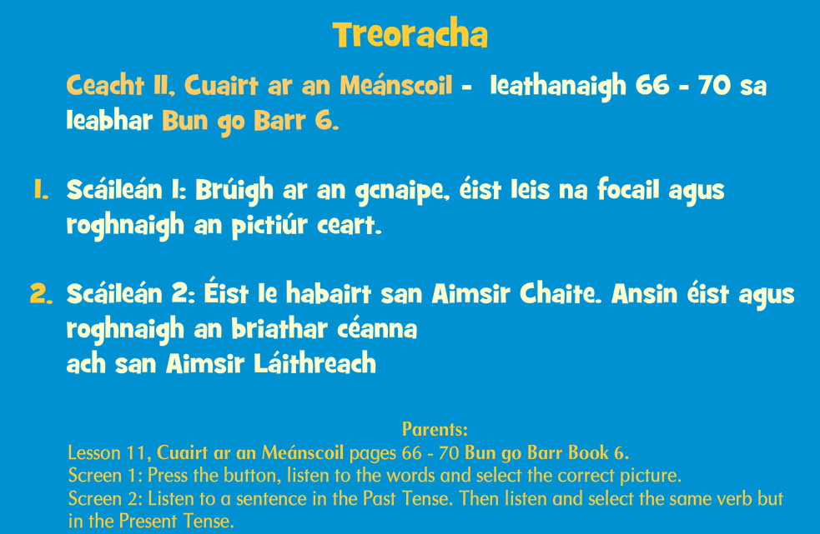
Bun go Barr - http://data.cjfallon.ie/resources/Rang6_Ceacht11.html

Maths:
Complete the activities on Seesaw.
- Finding radius, diameter and circumference.
- I can label the parts of a circle.
SESE: History
The Holocaust – PowerPoint Presentation and Report
Following on from what we have learned in Above the Clouds you may be interested to read more about The Holocaust.
Report activity – You are a journalist and are asked to prepare a report about The Holocaust at the end of the war. Some hints and tips included in the document.
PE:
- PE lesson / workout with The Body Coach Joe Wicks every day. Can find his videos on this YouTube link https://www.youtube.com/user/thebodycoach1/featured
- Ms. Foley has some great active ideas on the school website. http://pulloughns.weebly.com/active-school.html
- Cosmic Kids Yoga on YouTube

Art:
Use the following images as inspiration to create an image from WWII
