Monday 18.05.2020
English:
Spellbound: Week 30 Pages 62-63
- Read through all the block words and use a dictionary to help you find the meaning of the following words: primitive, precise, precede, seize, scout
- Complete Exercise 1: Thesaurus Work: Some words may have more than one meaning depending on the context. Identify these block words from the clues.
- Learn Block 105
Above the Clouds: Monkey Mayhem Pages 98-105
- Pre – reading activities – Number 2: Comprehension Strategy is Connecting
- Read the full story in your book – Max joined his parents on a trip to Africa and drank from a stream. Since then he has a strange power. He can transform into animals. It only lasts a few hours but find out what he gets up to in the jungle.
- Complete Exercise A – A Little Light Thinking Q1-3
Grammar Revision – Nouns
- A common noun is the general name of a person, place, animal, thing or occasion.
- A proper noun is the specific name. Example: Emily, Cork
- A collective noun names a group of people, animals or things. Example: team, flock
- Page 43 Above the Clouds Exercise E 1-8
Gaeilge:
Léigh sa Bhaile: Seachtain 27 Lá 3 lth 107 – Imríonn Larry Leadóg (Caitheamh Aimsire)
- Léigh an scéal: http://data.cjfallon.ie/audio/LeighsaBhaile-E-p107.mp3 ctrl and click to listen to the story.
- Dictionary Work –tugann, caitheann, buaileann (Verbs in the Aimsir Láithreach.) https://www.teanglann.ie/ga/
Fuaimeanna agus Focail: Aonad 28 Na litreacha t agus th
- Ex A Líon na bearnaí le t nó th.
- Ex B Cuir an focail chearta sna habairtí.
- Bosca 1
Maths: 6th Class
Fractions/Decimals/Percentages
Matching Fractions Decimals and Percentages: This is a very good activity to introduce the topic on the CJ Fallon website. I will also post on Seesaw for easy access.
http://data.cjfallon.ie/resources/20714/BAM6_Tutorial_059/lessons/BAM6_Tutorial_059/index.html
Busy at Maths: Page 94 Complete Q1 Just like the activity above you have to find the matching sets of fractions, decimals and percentages. I will upload a bookmark resource to help you with this topic on our class blog on the website.
Mental Maths – Hopefully I will be able to send books out soon but for now I have attached document with a picture of each page. Please complete Monday. Take a picture and upload to Seesaw I can correct for you.
Tuesday 19.05.2020
English:
Spellbound: Week 30 Pages 62-63
- Complete Exercise 2: Unscramble the confused words in the sentences.
- Learn Block 106
Above the Clouds: Monkey Mayhem Pages 98-105
- Re-read the full story in your book – Max joined his parents on a trip to Africa and drank from a stream. Since then he has a strange power. He can transform into animals. It only lasts a few hours but find out what he gets up to in the jungle.
- Complete Exercise A – A Little Light Thinking Q4-6
Grammar Revision – Collective Nouns
- A collective noun names a group of people, animals or things. Example: team, flock
- Page 49 Above the Clouds Exercise E 1-10

Gaeilge:
Léigh sa Bhaile: Seachtain 27 Lá 3 lth 107 – Imríonn Larry Leadóg (Caitheamh Aimsire)
- Léigh an scéal: http://data.cjfallon.ie/audio/LeighsaBhaile-E-p107.mp3 ctrl and click to listen to the story.
- Ceisteanna 1-5
Fuaimeanna agus Focail: Aonad 28 Na litreacha t agus th
- Ex C Cuir le Chéile
- Ex D Scríobh 4 bhfocal ón liosta leis na litreacha
- Bosca 2
Maths: 6th Class
Fractions/Decimals/Percentages
Busy at Maths:
- Page 94 Question 3 Riddle
What goes up but never comes down? Order from the biggest to smallest to find the answer.
Hint: First letter is Y = 75.5%
- Page 94 Question 4: Complete the table
Use the bookmark for FDP to help you with this activity.
Mental Maths. Please complete Tuesday. Take a picture and upload to Seesaw I can correct for you.

Wednesday 20.05.2020
English:
Spellbound: Week 30 Pages 62-63
- Complete Exercise 3 Alphabetical Order – All the words from Block 105-106 that begin with the letter p. Use the letter clues in column B to help you. (Write out the alphabet to use as a visual if you are finding it difficult)
Above the Clouds: Monkey Mayhem Pages 98-105
- Exercise B Deeper Thinking Q1-3.
- Remember to use full sentences and always use evidence from the story to back up your answer. Q1. Why do you think Max felt so itchy? I believe the reason Max felt so itchy was because he was transforming into a Baboon. I think it was the “mat of bristly hair” which burst from every pore of his skin.
- Complete Exercise B – Deeper Thinking Q1-3
Grammar Revision – Treasury Page 27 Nouns
- Exercise A: Underline the common nouns, circle the proper nouns and tick the collective nouns. Complete 1-5
Gaeilge:
Léigh sa Bhaile: Seachtain 30 Lá 3 lth 119 – Club na bPáistí (Caitheamh Aimsire)
- Léigh an scéal: http://data.cjfallon.ie/audio/LeighsaBhaile-E-p119.mp3 ctrl and click to listen to the story.
- Dictionary Work – óstán, ealaín, bonn óir https://www.teanglann.ie/ga/
Fuaimeanna agus Focail: Aonad 28 Na litreacha t agus th
- Ex F Tóirfhocal. Faigh na focail
- Ex G Scríobh an focal ceart faoin bpictiúr
- Bosca 3
Maths: 6th Class
Fractions/Decimals/Percentages
- Expressing numbers as a percentage of each other. First write in fraction form and then multiply by 100 over 1
- http://data.cjfallon.ie/resources/20714/BAM6_Tutorial_060/lessons/BAM6_Tutorial_060/index.html
- Watch the tutorial above and then complete Question 1 in Busy at Maths Page 95.
- Question 1. A) $\frac{7}{28} x\frac{100}{1}=\frac{700}{28}=700 ÷28=25\%$ Now try b, c and d yourself.

Mental Maths. Please complete Wednesday. Take a picture and upload to Seesaw I can correct for you.

Thursday 21.05.2020
English:
Spellbound: Week 29 Pages 60 - 61
- Complete Exercise 4: Analogies – Use the block words to complete analogies. A) Ancient is to primitive as modern is to advanced.
- Learn Block 108
Above the Clouds: Monkey Mayhem Pages 98-105
- Exercise B Deeper Thinking Q4-6.
- Remember to use full sentences and always use evidence from the story to back up your answer. Q1. Why do you think Max felt so itchy? I believe the reason Max felt so itchy was because he was transforming into a Baboon. I think it was the “mat of bristly hair” which burst from every pore of his skin.
- Complete Exercise B – Deeper Thinking Q4-6
Grammar Revision – Treasury Page 27 Nouns
- Exercise B: Choose the correct nouns to complete the paragraph.
- Fill in the nine spaces.
Gaeilge:
Léigh sa Bhaile: Seachtain 30 Lá 3 lth 119 – Club na bPáistí (Caitheamh Aimsire)
- Léigh an scéal: http://data.cjfallon.ie/audio/LeighsaBhaile-E-p119.mp3 ctrl and click to listen to the story.
- Ceisteanna 1-5
Fuaimeanna agus Focail: Aonad 28 Na litreacha t agus th
- Ex E Críochnaigh na habairtí 1-5
- Ex H Crosfhocal
- Bosca 4
Maths: 6th Class
The Circle:
- Busy at Maths – Page 146
- Question 1: Can you name the parts of the circle represented by each letter.
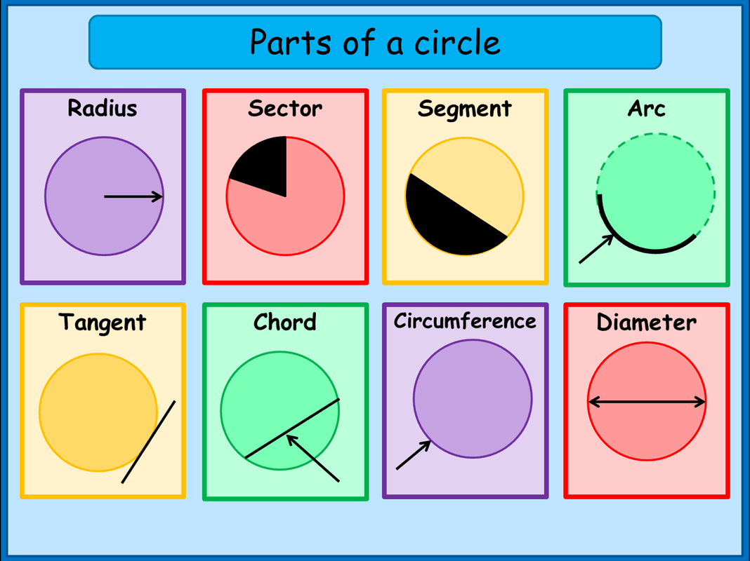
- Question 2: Can you pick out the three words needed to answer a, b, and c.

Mental Maths. Please complete Thursday. Take a picture and upload to Seesaw I can correct for you.

Friday 22.05.2020
English:
Spellbound: Week 30 Pages 62-63
- Complete Exercise 5: Unscramble the letters to make block words.
- Can do a test at home if you wish
Above the Clouds: Poetry Study
Page 106 – Monkey Me
- Name the poet?
- What reasons does the speaker in the poem give for wanting to become a monkey?
- What kind of person do you think the speaker is?
- Do you like/dislike this poem? Why?
Grammar Revision – Nouns KAHOOT TIME
After completing the exercises all week, you should be a pro at this Kahoot Quiz‼ Try it out!
Please use your proper name otherwise I don’t know who the player is.
https://kahoot.it/challenge/09909526?challenge-id=b5fcf698-f782-4d93-97a8-d0485c62fb60_1589728479179 GAME PIN: 09909526
Gaeilge:
Caitheamh Aimsire:
1. | Cad iad na caitheamh aimsire atá agat? | Is fearr liom a bheith ag imirt cispheile/ag imirt iomána/ag imirt peile/ag marcaíocht/ag dornálaíocht/ag damhsa/ag imirt leadóige/ag iascaireacht/ag snámh/ag imirt rugbaí.
2. | Cén caitheamh aimsire is fearr leat? | Is maith liom ___________ ach is fearr liom __________
3. | An maith leat ceol? | Is/ Ní maith liom __________. Tá mé in ann an bosca ceoil/ an feadóg/ an fidil/ an giotár a sheinm.
4. | An bhfuil tú in ann snámh? | Tá/ Níl mé in ann snámh

Caitheamh Aimsire Kahoot: https://kahoot.it/challenge/06220317?challenge-id=b5fcf698-f782-4d93-97a8-d0485c62fb60_1589729980515 GAME PIN: 06220317
Fuaimeanna agus Focail: Aonad 28 Na litreacha t agus th
- Can do a test at home if you wish.

Maths: 6th Class
The Circle: Chapter 28 Page 146
Remember the radius is half the diameter. So if the radius is 5cm the diameter of the circle is 10cm. If the radius is 20cm the diameter of the circle is 40cm. Likewise if the diameter of the circle is 100cm then the radius is half that, which is 50cm.
Now try to complete the grid in Question 5 on page 146.
*** Always remember these are only suggested activities. Don’t put yourself under pressure to complete everything if you are not able. You are learning many new skills at home and that is just as important at this time. S. Brady***

