6th Class
Yearbook
2020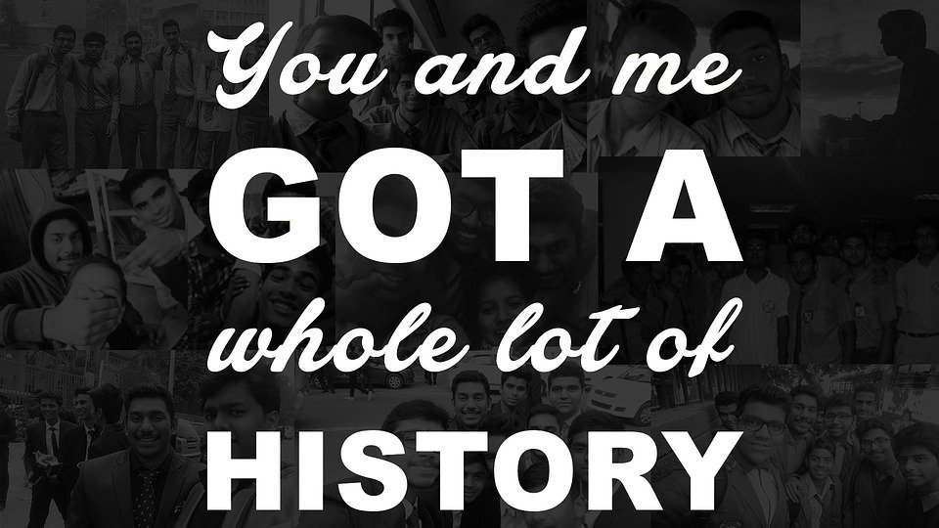

Created by
Rebecca Looby

6th Class 2020

Kody Molloy - Great at Football, has a strong sense of humour, big Chelsea fan.

Harry Delaney - funny, great at football and basketball, funny.

Hayden Delaney - strong sense of humour, smart, great at football, big Man City fan.

Keelan Bracken - great at football, funny, very tall.

Cian Molloy - Really smart, great goalkeeper, funny.

John Moran - Great at football, funny, big Man United fan.

Abbey Delaney - Great at writing stories, funny, great at football and basketball, great singer, loves stranger things.

Rebecca Nally - funny, great at football, big the vampire diaries fan.

Rebecca Looby - kind, brilliant at guitar and singing, really good at football, big Harry Potter fan.

Lauren Minnock - great at football, really funny, great singer, loves dogs, big Harry Potter fan.

Although we are missing out on some stuff we’ve been waiting years for we can still remember the things we DID get to do.
For instance:
- We got to go on taster days to Gallen CS and Killina together.
- We got to go to the Gallen play together.
- We got to see the Joker
- We got to have our Christmas show
- We got to go to Peace Proms
- We got to do our Robotics
- We got to play our autumn season of football. Well done to the boys for making it to the final!
This is a strange school year but we still have to have our yearbook. Stay home and stay safe and most importantly, Enjoy!

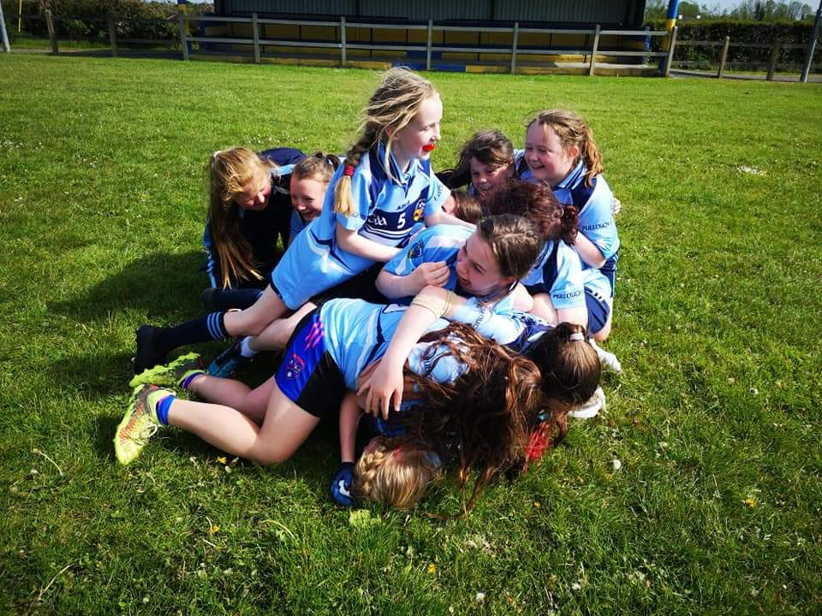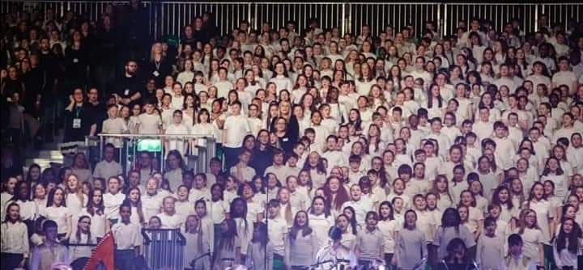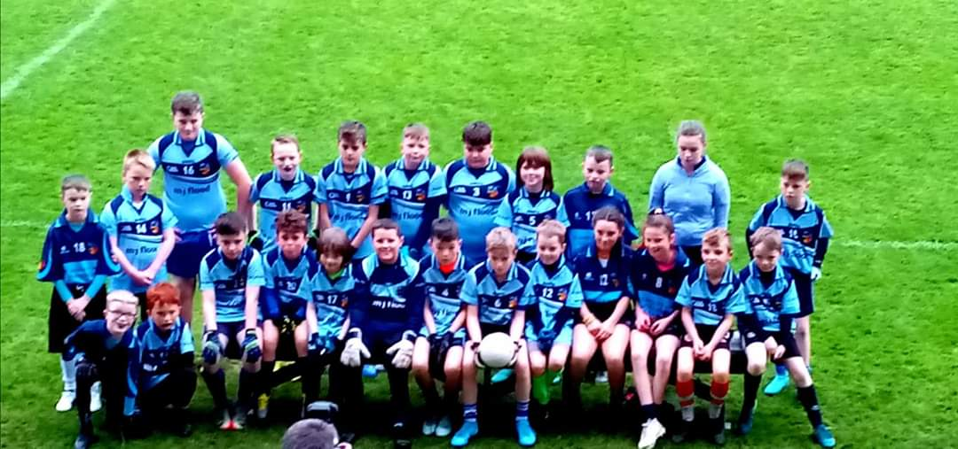

Sixth Class 2019 - 2020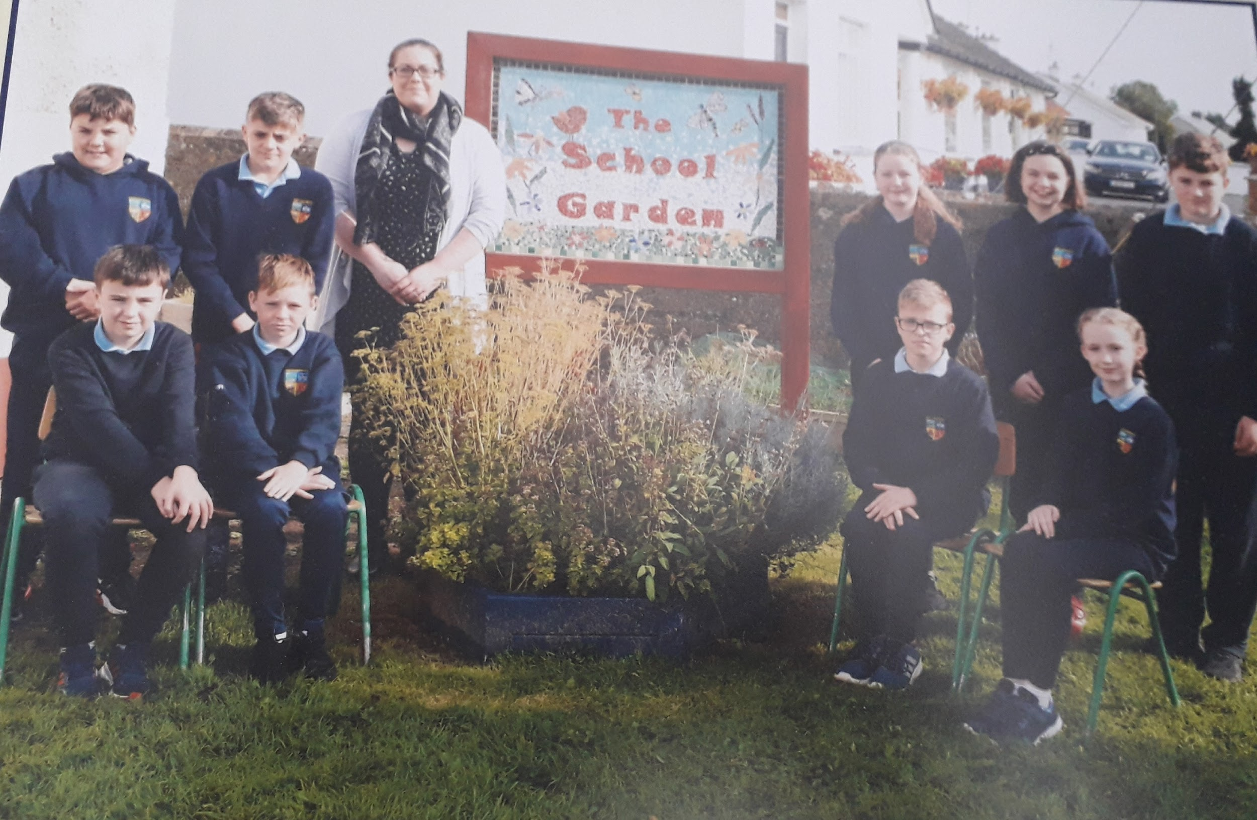

WORDSEARCH
J O H N K C T N K N K S R D L
Q Y V A I O E C O A D E I E N
D Y Q A R D K V A L B X D I Y
I S N H Y R C V K E V V W Z L
F L I A H H Y R C E H R Q I R
N Y H X K Q R C I K W Q J I P
J E R F O Y A Q F S E W X D C
E G R M D L Y W K F E C F U Z
O J S U Y G X F X V X J E X F
A X V E A B N H O J F Z B U A
W L P V V L T H F O F E A C A
T O A T M E Z U Y Y F P E T U
M C L M F N M N P C T C J T G
I H E V Q Q A B B E Y Q H Z S
E N A C C E B E R J S X W T K

Find our names;
ABBEY
CIAN
HARRY
HAYDEN
JOHN
KEELAN
KODY
LAUREN
REBECCAL
REBECCAN
Here’s a scroll and a hat that will hopefully remind you of what you achieved as we finish primary school. I hope it will remind you of all the good times we had together.
You did it!
You finished eight years of school!
Congrats!!!

Class Of 2020

Kody Molloy Cian Molloy

Keelan Bracken John Moran

Hayden Delaney Harry Delaney

Lauren Minnock Rebecca Looby

Abbey Delaney Rebecca Nally

