Monday 27.04.2020
English:
Spellbound: Week 27 Pages 56-57.
- Read through all the block words and use the internet to help you find the meaning of any words you don’t understand.
- Complete Exercise 1: Replace the block words in brackets with words taken from blocks 93-94 (This activity will help with your understanding of the words)
- Learn Block 93
Above the Clouds: Pg 107 - 110 Space Above Planet Mars
- Read the first three pages of Space Above Planet Mars. Don’t forget the pre-reading activities on page 107. Have a look for the tricky words in your dictionary/online and find out what they mean: hyperspace, hemisphere, atmosphere, translucent, Sentinel, obelisk, oxidised, juxtaposition
- A Little Light Thinking Questions 1-5 (All answer can be found in the first three pages)
- Challenge: Write the names of the eight planets in our Solar System.
Gaeilge:
Léigh sa Bhaile: Seachtain 24 Lá 1 lth 93 – Cuairt ar mo Chol Ceathrair 1
- Léigh an scéal: http://data.cjfallon.ie/audio/LeighsaBhaile-E-p93.mp3 ctrl and click to listen to the story.
- Dictionary Work – sceitimíní, ag fanacht, tráthnóna https://www.teanglann.ie/ga/
Fuaimeanna agus Focail: Aonad 23 lth 70-72
- Ex A Líon na bearnaí le m nó mh.
- Ex B Cuir an focail chearta sna habairtí.
- Bosca 1
Maths: 6th Class
Time: Distance, Speed and Time (DST)
Please have a look at this YouTube video first before we head over to the book. It explains how to find the distance, speed or time travelled using three simple formulas. If you follow the method each time you should have no problems. https://www.youtube.com/watch?v=8glfUANjBbY
Can you try these for me?
- A train was travelling at an average speed of 60km/h. How long does it take to do a journey of 240km?
- It takes two hours for a fast ferry to sale between Dún Laoghaire and Holyhead, a distance of 110km. what is the average speed in km/h?
- Ciarán cycled at an average speed of 33km/h for 50mins. What distance did he travel?
Take a picture of your answers and upload to your journal on Seesaw. I can correct them for you.
Tuesday 28.04.2020
English:
Spellbound: Week 27 Pages 56-57.
- Complete Exercise 2: Separate the words from blocks 95 and 96 according to the amount of syllables they have
- Learn Block 94
Above the Clouds: Pg 107 - 110 Space Above Planet Mars
- Read pages 11,112,113 of Space Above Planet Mars. Don’t forget the post-reading activities on page 113.
- Exercise B Deeper Thinking questions 1-6
Gaeilge:
Léigh sa Bhaile: Seachtain 24 Lá 1 lth 93 – Cuairt ar mo Chol Ceathrair 1
- Léigh an scéal: http://data.cjfallon.ie/audio/LeighsaBhaile-E-p93.mp3 ctrl and click to listen to the story.
- Ceisteanna 1-5
Fuaimeanna agus Focail: Aonad 23 lth 70-72
- Ex C Cuir le Chéile
- Ex D Scríobh 4 bhfhocal ón liosta leis na litreacha seo
- Bosca 2
Maths: 6th Class
Time: Distance, Speed and Time (DST)
- Review YouTube Video from yesterday. https://www.youtube.com/watch?v=8glfUANjBbY
- Busy at Maths: Pg 97 Have a look at the examples at the top of the page.
- Complete: Time Q1. Speed Q5 and Distance Q8
Take a picture of your answers and upload to your journal on Seesaw. I can correct them for you.

Wednesday 29.04.2020
English:
Spellbound: Week 27 Pages 56-57.
- Complete Exercise 3: Al words. Use the block words ending with al to solve these unusual clues.
- Learn Block 95
Above the Clouds: Pg 107 - 110 Space Above Planet Mars
- Review Space Above Planet Mars
- Writing Task linked to Story: Free Writing
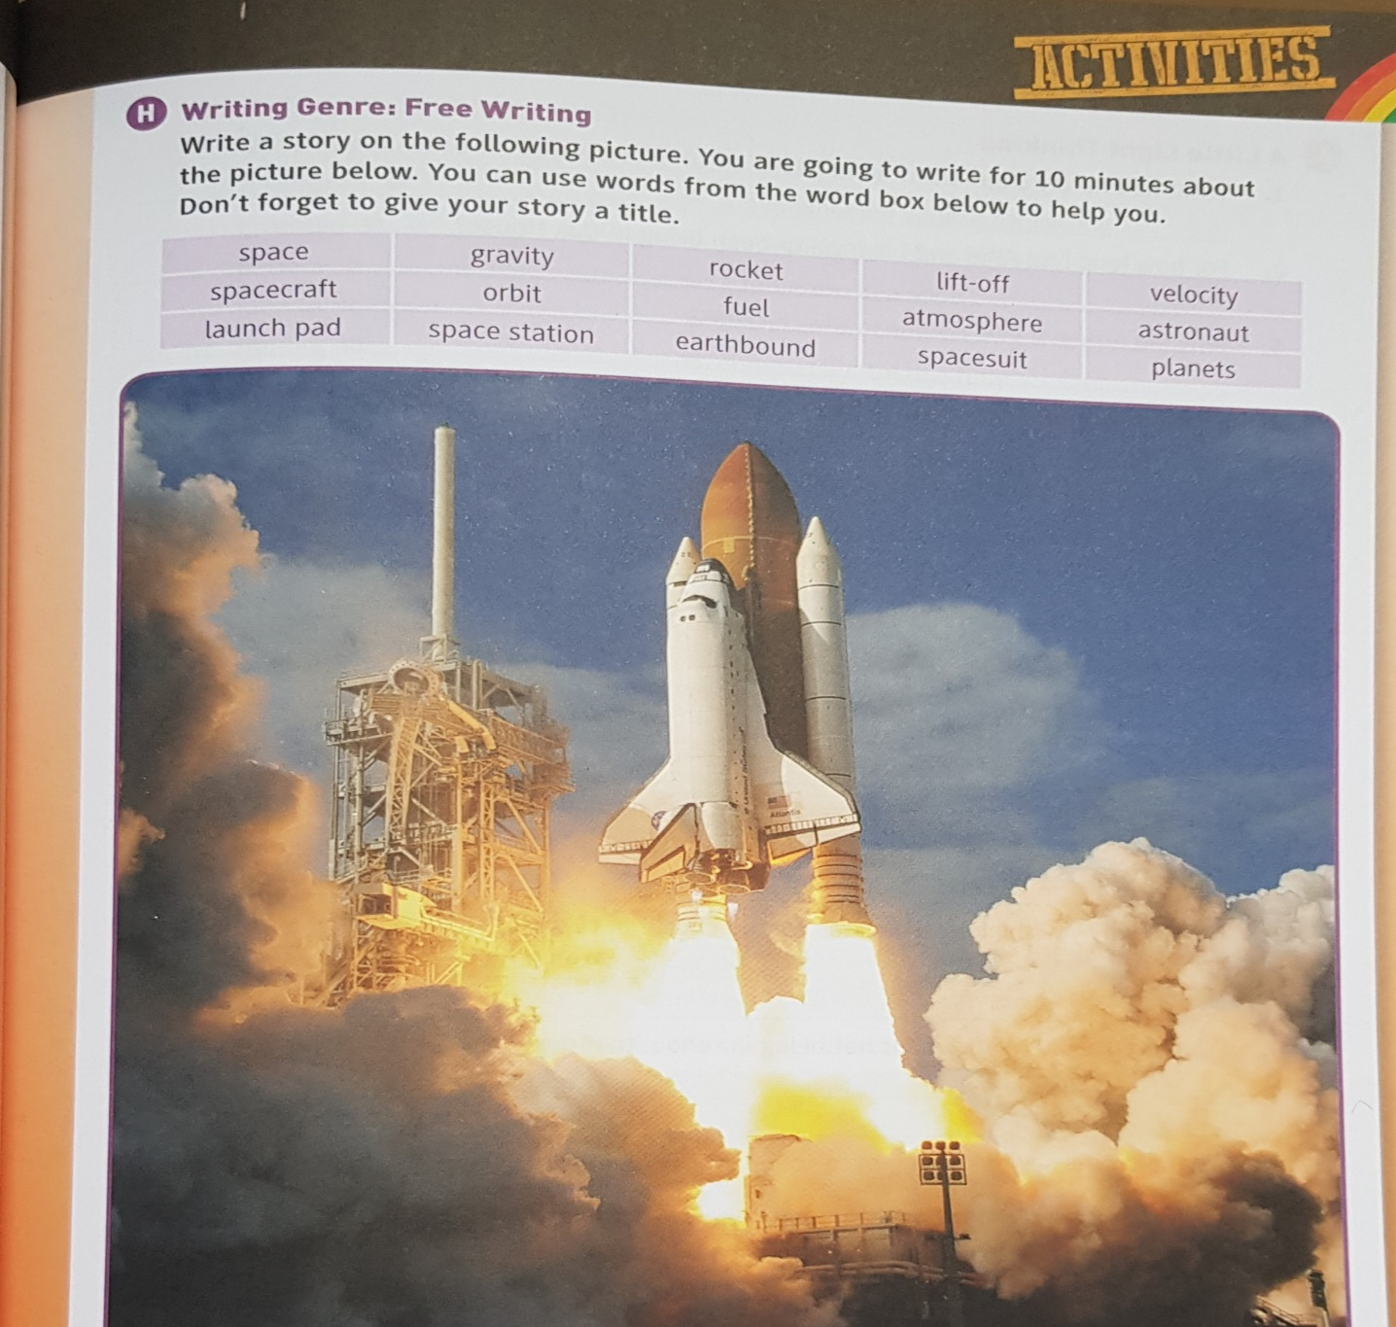

Gaeilge:
Léigh sa Bhaile: Seachtain 24 Lá 2 lth 97 – Cuairt ar mo Chol Ceathrair 2
- Léigh an scéal: http://data.cjfallon.ie/audio/LeighsaBhaile-E-p97.mp3 ctrl and click to listen to the story.
- Dictionary Work: ar chlé, an-lá https://www.teanglann.ie/ga/
Fuaimeanna agus Focail: Aonad 23 lth 70-72
- Ex F Scríobh an focal ceart faoin bpictiúr.
- Ex G: Faigh na focail seo:
- Bosca 3
Maths: 6th Class
Time: Distance, Speed and Time (DST)
- Review YouTube Video from yesterday. https://www.youtube.com/watch?v=8glfUANjBbY
- Busy at Maths: Pg 97 Have a look at the examples at the top of the page.
- Complete: Time Q2, Speed Q6, Distance Q9
Take a picture of your answers and upload to your journal on Seesaw. I can correct them for you.

Thursday 30.04.2020
English:
Spellbound: Week 27 Pages 56-57.
- Complete Exercise 4: Unjumble the confused words in these sentences. Write them
- Learn Block 96
Above the Clouds: Space Exploration pg 117
- Read Pg 117 -119
- Don’t forget the pre-reading and post-reading activities.
Gaeilge:
Léigh sa Bhaile: Seachtain 24 Lá 2 lth 97 – Cuairt ar mo Chol Ceathrair 2
- Léigh an scéal: http://data.cjfallon.ie/audio/LeighsaBhaile-E-p97.mp3 ctrl and click to listen to the story.
- Ceisteanna 1-5
Fuaimeanna agus Focail: Aonad 23 lth 70-72
- Ex H: Crosfhocal
- Bosca 4
Maths: 6th Class
Time:
- Page 98 Busy at Maths
- Question 1 a,b and c – Interpret the bar chart
Take a picture of your answers and upload to your journal on Seesaw. I can correct them for you.

Friday 01.05.2020
English:
Spellbound: Week 27 Pages 56-57.
- Complete Exercise 5: Synonyms – Write an associated block word for each
- Spelling Test if you wish
Above the Clouds: Space Exploration pg 117
- Read Pg 117 -119
- Exercise C – Vocabulary work.
- Challenge – What do you think are the most important things people would need in order to survive on Mars.
Gaeilge:
Fuaimeanna agus Focail: Aonad 23 lth 70-72
- Spelling test if you wish.
Maths: 6th Class
International Time Zones:
- Page 99 Busy at Maths
- The Earth has 24 different time zones. These are measured in one-hour intervals. Each 15 degree of longitude on the map represents one hour.
- Try to complete the table at the bottom of the page. Question 1
- Remember to watch out for East and West and how many degrees you need to move.
Take a picture of your answers and upload to your journal on Seesaw. I can correct them for you.

Maths: 5th Class
Mrs White will post a separate document for the fifth class students. Reminder Master your Maths should be done each day with a test on the fifth day.

