1st Class work - Week beginning 25th May – 29th May
I know this week the children in 2nd class should have received their First Holy Communion and as is tradition in the school the boys and girls in first and second class usually receive a homework pass on the Monday following the Communion. There will be no work to be completed on Monday. I have put up a small slideshow on Seesaw of some of the class photos we had taken throughout the school year and some you have sent us of the last few weeks. Go on and have a look and enjoy! This week will be a short week as we were due to have no school Friday and for the bank holiday so enjoy this break from the work.
Please see suggested daily activities for this week in the document below. I am looking forward to hearing from you all on Seesaw again this week and seeing all your videos, photos and learning at home. Keep up all the great work boys and girls!
If you have any questions or need any help please do not hesitate to get in touch on elaine.gallagher@pulloughns.com and as always I will help and support you in any way that I can.
Song of the week: Count on me (Bruno Mars)
Please register on Dabbledoo Music if you were unable to do so previously. The link is provided below- Choose Parents Subscription and then go to the link ‘Pop Songs for children’- This is a very fun and safe website and you will find the song and lyrics for this week’s song ‘Count on me’ here- https://dabbledoomusic.com/

Monday 25th May
- Check out the class memories slideshow on Seesaw
Tuesday 26th May
English
- Rainbow skills book you can work away as time permits revising grammar and various exercises throughout the week.
- Handwriting Book- can also be completed at your discretion throughout the week to keep up your letter formation and written presentation skills.
- Reading: - Please continue to complete some daily reading, use books you have at home or use the links provided previously for levelled books that are available online. This week I would like you to continue your focus on your word work. Just like we do in class during our reading sessions. An adult can ask you to find lots of words in your reader and this week I want you to focus on finding some verbs.
**Remember** A verb is a part of speech that is often used to describe an action. It is a doing word. Eg. The dog ran down the street. Ben opened the refrigerator to get the lemonade.
- Read at Home: We have finished our Read at home, please choose a story that you liked and answer the questions orally.
- Spellbound: Week 32- Revision - Exercise 1 & 2
- Sounds like Phonics: Plural words p81
- Seesaw activity: Underline the noun, circle the verb.

Gaeilge
- Léigh sa Bháile lth.115 – Lá Fliuch – http://data.cjfallon.ie/audio/LeighsaBhaile-A-p115.mp3
- Bua na Cainte – Using interactive website downloaded previously or there is now access to each daily lesson which we have uploaded to Seesaw for your convenience also.
- Select- Téama - Sa Bhaile - Ceacht 10
- Select the yellow speech bubble at the bottom of the page
- Click on the little mouse icon on the lower left hand side of the page for text during the interactive video.
- Fáilte romhat isteach – (You are welcome in/Come in)
- Go raibh maith agat - Thank you
- Suigh síos agus lig do scith – Sit down and rest yourself/take it easy
- Suífidh mé – I will walk
- Ar mhaith leat – Would you like
- Ba mhaith liom - I would like
- Níor mhaith liom – I wouldn’t like
- Tá/Níl – Yes/No
- Ar fheabhas – Brilliant/Fantastic
- Complete the interactive games under the games function, you will only be able to do this if you have downloaded Bua na Cainte to a laptop.

Maths
- Master your Maths: Go back through your book and see is there any catch up work you need to complete. See can you recognise any common mistakes you have made. Are you able to do these now? Take on day at a time
- Tables: Revision + and - 12
- Busy at Maths: Counting in 6’s p129
SESE
- We are beginning to learn all about Irish birds and today I want to look at the PowerPoint all about the robin. Can you complete a fact file in your SESE copies about everything you have learnt and draw a picture of the robin?
- Seesaw activity: Watch the little video of robins in the nest on Seesaw.
- When you are in bed early in the morning and outside playing, see can you hear or see any birds in your garden, keep a good look out for them, what do they look like, where is their nest, what sounds do they make.
- If you have time during the week – research another Irish bird choose from this list – blackbird, swallow, thrush, wren, sparrow. www.birdwatchireland.ie is a great website to help you. You can upload it to Seesaw so I can see.
Art
Complete this nice art activity. Draw a hand from every member of your family on a page and colour it in with some lovely patterns, it will be a lovely memento to have. See an example below to give you an idea.
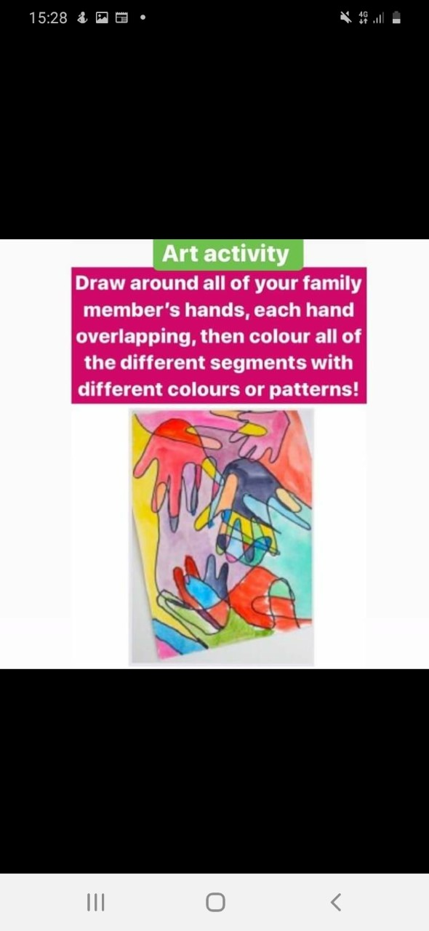

Wednesday 27th May
English
- Reading: - Please complete some daily reading, use books you have at home or use the links provided in the email last week for books that are available online.
- Reading - Go to https://my.cjfallon.ie/dashboard/resources on the task bar, click Primary Second Class-English, choose the book Wordwise and go to p2. Read the story Lost and complete the comprehension questions orally on p3.
- Spellbound: Week 32- Revision Exercise 3 and 4
- Sounds like Phonics: click on the following link https://slp.cjfallon.ie/ and choose Sounds Like Phonics Book D.
- Select Unit 4- The Mueseum Select: homophones
- Watch the video and complete the nice online activities
- Complete pg. 82 in your Sounds like Phonics book

Gaeilge
- Léigh sa Bhaile: lth.115 – Lá Fliuchhttp://data.cjfallon.ie/audio/LeighsaBhaile-A-p115.mp3
- Bua na Cainte:
- Select- Téama - Sa Bhaile - Ceacht 10
- Go back over the video from yesterday and practise the vocabulary above.
- Complete the activity on lch 82
Maths
- Go back through your book and see is there any catch up work you need to complete. See can you recognise any common mistakes you have made. Are you able to do these now?Take on day at a time
- Tables: Revision + and - 12
- Busy at Maths: Looking at pattern, counting in groups, read the question, work out the answer for 1 first the add, remember your skip counting in class. Complete p140
Music
- Dabbledoo Music - Learn and practise the song Count on me - put your own dance routine to it.

SPHE/ Religion
- Say your prayer ‘Hail Mary’ again this week to mark the last week of the month of Mary.
- Learning about being kind and looking out for one another - ask your child to sit quietly, close their eyes and listen to your voice. Ask the children to think of the last time someone did something kind for them. This could be lending a something, helping them, a compliment on a job well done; a compliment on work well done; someone saying thank you for something you did; listening carefully.
- Ask the children to think about how little acts of kindness make them feel - usually when people are kind it could make us feel happy, warm, relaxed, appreciated, or content.
- Next, ask them to think about something kind they could do for. Ask them to imagine themselves doing it and how it will make them feel and how the person to whom they are being kind will feel. Now ask them to think of another way of being kind. Ask them to imagine this as well, where they will be, how they will stand, what they will say…
- Tell them that from now on we are going to make sure to do lots of acts of kindness.
- In a copy tell them they are going to record a kind thing someone does for them each day and a kind thing they do for someone else. They can do this in pictures and words or use words only. Try and see can you do it for a week.
Thursday 29th May
English
- Reading: Continue to read the book you have chosen this week. Two pages a day is sufficient and do lots of word work, remember you are searching for lots of verbs this week!
- Reading - Go to https://my.cjfallon.ie/dashboard/resources on the task bar, click Primary -Second class-English, choose the book Wordwise and go to p6 Read the story Clever girl saves Kitten and complete the comprehension questions orally on p7.
- Poetry - Read the poem The night I met a hedgehog – can you think of a time you saw a hedgehog or an animal in your garden, what was it like how did you feel. Could you write your own poem about it, use an Acrostic poem, remember you use the word Hedgehog and write your own words, with the sentence starting with the corresponding letter.
- Spellbound: Week 32 Revision Exercise 5
- Sounds like Phonics: p 83 Name, label and colour.

Gaeilge
- Léigh sa Bháile lth.116- Spórt http://data.cjfallon.ie/audio/LeighsaBhaile-A-p116mp3
- Bua na Cainte – Using interactive website downloaded.
- Select- Téama - Sa Bhaile - Ceacht 11
- Select the yellow speech bubble at the bottom of the page
- Click on the little mouse icon on the lower left hand side of the page for text during the interactive video
- Tháinig - Came
- Ba bhréa liom - I would like
- D’oscail – opened
- Thug - gave
- Uachtar reoite – ice-cream
- An sásta – very happy.
- Complete the interactive games- you will only be able to do this if you have Bua na Cainte downloaded to your laptop.
- Complete the activity on p83
Maths
- Go back through your book and see is there any catch up work you need to complete. See can you recognise any common mistakes you have made. Are you able to do these now? Take on day at a time
- Tables: Revision + and - 12
- Busy at Maths: Looking at pattern, practise counting forwards and backwards out loud in 2’s, Start at different points. Complete the activity on p140
PE
Choose one of the following activities;
- Choose an activity from your Active Choice Board – sent after the Easter break
- Complete some of the activities listed by Ms. Foley on the school website. Go to School activities – Active School and see some suggestions listed there for variety
- Joe Wicks – The Bodycoach- You tube
https://www.youtube.com/channel/UCAxW1XT0iEJo0TYlRfn6rYQ

